THE EFFECT OF RHIZOBIUM STRAIN, PHOSPHORUS APPLIED,

AND INOCULATION RATE ON NODULATION AND YIELD OF

SOYBEAN (GLYCINE MAX (L.) MERR. CV. 'DAVIS')

A THESIS SUBMITTED TO THE GRADUATE DIVISION OF THE
UNIVERSITY OF HAWAII IN PARTIAL FULFILLMENT
OF THE REQUIREMENTS FOR THE DEGREE OF

MASTER OF SCIENCE

IN

AGRONOMY AND SOIL SCIENCE

DECEMBER, 1986

BY

Ronnie C. Nyemba

Thesis Committee:

Ben B. Bohlool, Chairman
Paul W. Singleton
James A. Silva

We certify that we have read this thesis and that in our opinion it is satisfactory in scope and quality as a thesis for the degree of Master of Science in Agornomy and Soil Science.
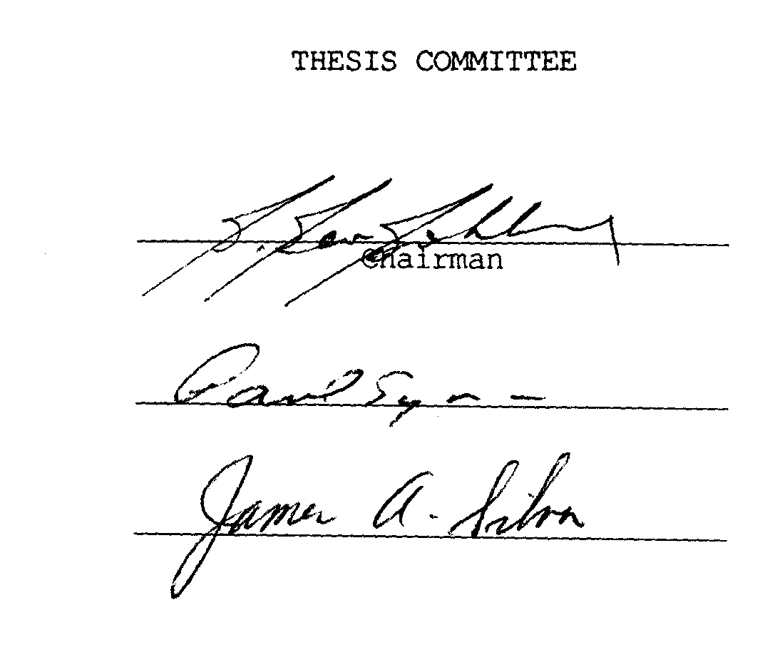

ACKNOWLEDGEMENTS

I am grateful to the Goverment of the Republic of Zambia and to the ZAMARE Project, (University of Illinos, Urbana-Champaign), for supporting me financially during my training.
My sincere gratitude goes to the NIFTAL Project (University of Hawaii) for the material facilities that enabled me to conduct this experiment. In addition, NIFTAL Project made it possible for me to come to Hawaii by sending a member of their staff to Zambia to continue my duties while I was on training.
I thank Dr. B. B. Bohlool, Dr. P. W. Singleton, and Dr. J. A. Silva for being on my advisory committee, Mr. K. Keen, Mr. K. Cavagan, and Mr. J. Tavares without whose invaluable help this experiment would have been extremely difficult to conduct.
I will always be indebted to Ms. B. Voigt for teaching me how to use the word processor on her computer during the preparation of this thesis.
Finally, my thanks go to all members of staff at NIFTAL Project who helped me plant and harvest the experiment.
TABLE OF CONTENTS

Page

ACKNOWLEDGEMENTS...................................................3

LIST OF TABLES.....................................................8
LIST OF FIGURES....................................................10
CHAPTER I. INTRODUCTION............................................11
CHAPTER II. LITERATURE REVIEW......................................15
2.1 Phosphorus in Tropical Soils........................15

2.1.1 Content and forms of phosphorus.............15
2.1.2 Availability of phosphorus in
tropical soils..............................15

2.2 Phosphorus Requirements of Soybean..................17
2.2.1 Accumulation and translocation of
phosphorus during growth....................17

2.2.2 Growth and nodulation response to
phosphorus fertilization....................18

2.3 Growth Response of Rhizobium japonicium to
Concentration of Phosphorus.........................21

2.4 Inoculation of Soybean with Rhizobim
japonicum...........................................22

2.4.1 Need to inoculate...........................22

2.4.2 Adequacy of inoculation.....................24

2.5 Assessment of Nitrogen Fixation.....................27

2.5.1 Plant growth characteristics................27

2.5.1.1 Modulation...........................28
2.5.1.2 Yield................................28
2.5.1.3 Nitrogen.............................29

2.5.2 Methods of estimating nitrogen
fixation....................................29

TABLE OF CONTENTS (Continued)

Page

CHAPTER III. MATERIALS AND METHODS................................30

3.1 Experimental Site..................................30

3.2 Field Preparation and Fertilization................30

3.3 Inoculum Preparation, Seed Inoculation
and Planting.......................................31

3.3.1 Preparation of inoculants..................31
3.3.2 Inoculation of seed........................31

3.3.3 Planting...................................33
3.4 Sample Harvest and Tissue Analysis.................33

3.4.1 Sample collection at 50% flowering......... 34

3.4.2 Sample collection at physiological
maturity...................................34

3.4.3 Tissue analysis.............................35

3.5 Data Analysis......................................35

3.6 Experimental Design................................35
CHAPTER IV. RESULTS...............................................36

4.1 Effect of Strain of Rhizobium, Phosphorus
Applied, and Inoculation Rate on Nodulation
at 50% Flowering...................................36

4.1.1 Effect of the interaction between
strain and inoculation rate on
nodule dry matter..........................36

4.1.2 Effect of the interaction between
phosphorus applied and inoculation
rate on nodule dry matter..................39

4.1.3 Main effect of the inoculation rate
on the average weight of a nodule..........39
4.1.5 Nodule identification......................41

4.1.6 Nodule placement...........................41
TABLE OF CONTENTS (Continued)

Page

4.2 Main Effects of Phosphorus Applied
and Inoculation Rate on Plant Growth
Paramers at 50% Flowering..........................42

4.2.1 Main effects of phosphorus
applied on plant growth....................42

4.2.2 Main effects of inoculation rate
on plant growth parameters.................42

4.2.3 Effect of the interaction between
strain and inoculation rate on
concentration of nitrogen in the
shoot......................................44

4.3 Effects of Phosphorus Applied and
Inoculation Rate on Plant Growth at
Physiological Maturity.............................48

4.3.1 Main effects of inoculation rate
on plant growth parameters.................48

4.3.2 Effect of the interaction between
strain and phosphorus applied on
plant growth parameters....................52

4.3.2.1 Dry matter..........................52 4.3.2.2 Seed yield (13% moisture)...........56 4.3.2.3 Total nitrogen......................57 4.3.2.4 Plant P uptake......................58 4.3.2.5 Harvest index.......................59

CHAPTER V. DISCUSSION.............................................60
5.1 Nodulation.........................................61
5.1.1 Nodule placement...........................62

5.1.2 Effect of inoculation rate.................62

5.1.3 Effect of phosphorus fertilization.........63

5.2 Plant Growth and Accumulation of Nitrogen
and Phosphorus.....................................65

5.2.1 50% flowering stage........................65

5.2.2 Physiological maturity stage...............67
TABLE OF CONTENTS (Continued)

Page

CHAPTER VI. SUMMARY AND CONCLUSIONS..............................72

APPENDIX A. Nodule Occupation by Strains USDA
110 and USDA 142 as Identified from Nodules
Produced by Plants Inoculated with the
Mixed-Strain Inoculum................................76
APPENDIX B. Harvest Index as Affected by
Inoculation Rate.....................................80

APPENDIX C. Regression Equations Relating
Soybean Nodulation and Growth Parameters at
Flowering and Maturity to Strain, Phosphorus,
and Inoculation Rate; Correlation Coefficients
amoung Plant Growth Parameters at Flowering and
Maturity............................................. 82

LITERATURE CITED.................................................86
LIST OF TABLES

Table Page

1 Analysis of variance for nodulation parameters at 50%
flowering as affected by strain, phosphorus applied,
and inoculation rate...........................................36

2 Treatments effects on the average weight of a nodule (mg)
at 50% flowering...............................................41

3 Analysis of variance for plant growth parameters at 50%
flowering as affected by strain, phosphorus applied,
and inoculation rate...........................................43

4 Main effects of phosphorus applied on plant growth
parameters at 50% flowering....................................43

5 Concentration of nitrogen in the shoot at 50% flowering
(g N kg⁻¹) as affected by the interaction between strain
and inoculation rate...........................................44

6 Analysis of variance for plant growth parameters at
physiological maturity as affected by strain,
phosphorus applied, and inoculation rate.......................49

7 Main effects of phosphorus applied on P uptake (kg ha⁻¹)
at physiological maturity......................................59

8 Percent means of nodules occupied by strains USDA 110
and USDA 142 averaged over both levels of phosphorus
applied and all inoculation rates..............................78

9 Percent nodule occupancy by strains USDA 110 and USDA
142 within levels of phosphorus applied........................79

10 Main effect of inoculation rate on the harvest index at
physiological maturity.........................................81

11 Regression equations relating soybean nodule dry weight
at 50% flowering to strain, phosphorus applied, and
inoculation rate...............................................83

12 Regression equations relating soybean growth parameters
at 50% flowering to strain, phosphorus applied, and
inoculation rate...............................................83

LIST OF TABLES (Continued)

Table Page

13 Regression equations relating soybean growth parameters
at physiological maturity to strain, phosphorus applied,
and inoculation rate...........................................84

14 Correlation coefficients (r) among plant growth
parameters at 50% flowering....................................84

15 Correlation coefficients (r) among plant growth
parameters at physiological maturity...........................85
LIST OF FIGURES

Figure Page
1 Field layout illustrating treatment randomizations
within a subplot and within a replicate........................32

2 The relationship between the number of nodules and
nodule dry weight (g) at 50% flowering.........................37

3 Nodule dry matter at 50% flowering as affected by the
interaction between strain and inoculation rate................38

4 Nodule dry matter at 50% flowering as affected by
the interaction between phophorus applied and
inoculation rate...............................................40

5 Main effect of inoculation rate on shoot dry matter
at 50% flowering...............................................45

6 Main effect of inoculation rate on accumulation of
nitrogen in the shoot at 50% flowering.........................46

7 Main effect of inoculation rate on uptake of
phosphorus by the shoot at 50% flowering.......................47

8 Main effect of of inoculation rate on total dry
matter and seed yield at physiological maturity................51

9 Main effect of inoculation rate on total
nitrogen uptake, and on the amount of nitrogen
accumulated by the seed at physiological maturity..............54
10 Main effect of inoculation rate on total
phosphorus uptake and on the amount of phosphorus
accumulated by the seed at physiological maturity...............55
11 Total dry matter at physiological maturity as
affected by the interaction between strain
treatment and phosphorus applied................................56

12 Seed yield at physiological maturity as affected
by the interaction between strain treatment and
phosphorus applied.............................................57

13 Total nitrogen accumulated at physiological maturity
as affected by the interaction between strain
treatment and phosphorus applied...............................59

I. INTRODUCTION

Plants, like all other organisms, require nitrogen (N) and phosphorus (P) to grow and reproduce. Nitrogen is an essential constituent of proteins, nucleic acids, some carbohydrates, lipids, and many metabolic intermediates involved in synthesis and transfer of energy molecules (Viets. Jr., 1965; Davis, 1980). Phosphorus plays a fundamental role in the very large number of enzymic reactions that depend on phosphorylation. Phosphorus is essential for cell division and development of meristem tissue (Russel, 1973). Collectively, deficiency of these nutrients results in stunted shoot and root growth due to reduced cell division and reduced cell enlargement. Deficiency of nitrogen is visibly exhibited by the familiar pale yellow color of the leaves due to lack of chlorophyll synthesis.
Viets. Jr. (1965) reported that, worldwide, crops were more deficient in nitrogen supply than any other nutrient. This was evidenced by the relationship between cereal production and fertilizer usage (App and Eaglesham, 1982) which attributed one-third to one-half of the increase in cereal yields to use of nitrogen fertilizer. According to Stangel (1979), less developed countries used only about one-third of the world's total consumption of nitrogen fertilizer. Indeed, both Sanchez, (1976) and Fox, (unpublished) agreed that a listing in order of importance of soil fertility problems in the tropics would place nitrogen deficiency first and phosphorus deficiency second.
Unlike cereals, most agriculturally important members of the plant family Leguminosae are potentially capable of supplying their own nitrogen requirements in symbiosis with soil inhabiting bacteria, Rhizobium, (Trinick, 1982). The bacteria infect roots of the host plant and cause formation of nodules, which are the site of an enzymatic system (nitroganase) that is responsible for reduction of atmospheric nitrogen (N₂) into ammonia (NH₃). Ammonia is subsequently combined with organic acids to form amino acids which are the building blocks of protein molecules (Sloger, 1976; Davis, 1980). To the extent that legumes are: potentially capable of supplying their own nitrogen requirement through symbiosis, deficiency of phosphorus remains the most limiting of the major nutrients to legume production in the tropics for two principal reasons: (a) the adsorption of phosphorus by tropical soils and the insufficient resources available have increased the difficulty of supplying adequate fertilizer phosphorus for plant growth (Fox and Kang, 1977; Uehara, 1977); (b) phosphorus is required by nitrogen fixing plants to supply the energy, (ATP), necessary to drive complex enzymic reactions involved in nitrogen fixation (Shanmugan et al., 1978) as well as to maintain nodule tissue and for normal plant growth. This suggests that plants dependent on symbiotic nitrogen may require more phosphorus than plants supplied with mineral nitrogen (Franco, 1977).
Nitrogen fixation effectiveness of a legume-Rhizobium symbiotic association is dependent on biological factors such as host-strain specificity and environmental factors which affect the multiplication and growth of rhizobia in the environment. A detailed discussion of these factors is beyond the scope of this review. Suffice it to mention that it is important for the rhizobia to survive in the environment in order to effect nodulation. Damirgi et al. (1967) and Bohlool and Schmidt (1973) observed that strains of Rhizobium varied in ability to survive in soil. Ability to survive depends on tolerance by the strain to prevailing unfavorable conditions. For example, Kvien and Ham (1985) observed that an indigenous strain of Rhizobium was more adapted to prevailing soil temperatures than three introduced strains. Singleton et al. (1982) reported that Rhizobium strains surviving longer in saline environments were also more able to grow in solutions with electrical conductivities of up to 43.0 mS cm⁻¹. Damirgi et al. (1967) observed a positive correlation between the ability of a strain to form nodules and its tolerance to the pH of the medium in which the host plant was grown.
According to Burton (1976), successful nodulation is dependent on inoculation sufficiency and the effectiveness of the Rhizobium strain. The former concerns numbers of rhizobia and whether or not they are able to bring about adequate nodulation while the latter is related strictly to nitrogen fixing ability of the legume-Rhizobium association. When environmental conditions are not favorable, inoculation sufficiency can be improved by inoculating the host legume with a large population of the selected strain, or, by selecting a strain that is tolerant of the prevailing conditions.
Recent reports have indicated that, under phosphorus stress, strains of Rhizobium differed in their ability to extract and incorporate phosphorus from the external environment (Beck and Munns, 1984). The difference in ability to extract and store phosphorus intracellularly was found to be directly related to the ability of the strain to grow in liquid culture when concentration of phosphorus was low. There is need, therefore, to determine in a field with high phosphorus adsorption rapacity; (a) whether a Rhizobium strain able to grow in low concentrations of phosphorus has a competitive advantage for nodulation when inoculation is inadequate, and, (b) whether the competitive: advantage translates into increased plant growth.
Rhizobia need to grow in the soil environment in order to effect adequate nodulation. Tolerance to low phosphorus by rhizobia would be especially important in developing countries of the tropics where inadequate resources are limiting efforts to alleviate phosphorus deficiency. Use of low quality inoculants and/or inadequate inoculation may also contribute to poor survival of introduced rhizobia and poor modulation by soybeans.
A field experiment was conducted on a Humoxic Tropohumult in order to determine:
a) The relationship between phosphorus fertility, inoculation rate and nodulation by two strains of R. japonicum differing in in vitro tolerance to phosphorus concentration.
b) The effect of interaction between strain of R. japonicum, phosphorus fertility, and inoculation rate on nitrogen accumulation and yield of soybeans.
II. LITERATURE REVIEW

2.1 Phosphorus in Tropical Soils
2.1.1 Content and forms of phosphorus
The total amount of phosphorus in tropical soils ranges widely from 200 ppm in highly weatherd Ultisols and Oxisols to about 3000 ppm in Andepts. Twenty to eighty percent of the total phophorus is bound in the organic matter fraction and the rest exists as inorganic compounds of Ca, Al and Fe (Sanchez, 1976; Adepetu and Corey, 1977; Fox and Searle, 1978). Since concentrations of Al and Fe increase with weathering of the soil, the proportion of the more soluble calcium phosphates decreases as they are transformed into the less soluble phosphates of Al and Fe (Sanchez, 1976).
2.1.2 Availability of phosphorus in tropical soils
Despite the considerable amount of total phosphorus contained by tropical soils, phosphorus deficiency is one of the most important fertility problems in tropical agriculture (Miller and Ohlrogge, 1957; Bieleski, 1973; Fox and Kang, 1977). Experimental evidence has indicated that the immediate source of phosphorus for plant growth is soil solution. Therefore, total amount of phosphorus does not not have a direct effect on plant response. Uehara (1977), Fox and Searle, (1978), and, Velayutham (1980) discuss in detail the factors and mechanisms that affect availability of phosphorus in tropical soil solutions.
An adequate level of phosphorus for most crops lies within the range 0.01 to 0.40 ug P ml⁻¹, 0.01 CaCl₂ (Kang and Juo, 1979). Most tropical soil solutions often contain less than 0.1 ug P ml⁻¹ (Bieleski, 1973; Fox and Kang, 1977), largely due to transformation of soluble monocalcium phosphates into the less soluble phosphates of Al and Fe, a process known as phosphate "fixation" or "adsorption" (Sanchez, 1976: Fox and Searle, 1978). Phosphate fixation increases with soil clay content, an indirect effect of the Al and Fe content (Uehara,1977; Velayutham,1980). Highly weathered Oxisols and Ultisols are usually acidic and tend to have high Al and Fe contents. Increasing the pH of the soil by liming reduces the concentration of Al and Fe in the soil solution. However, over the pH range that plants are normally grown, liming neither increases phosphate solubility nor does it decrease adsorption of phosphorus (Fox and Searle., 1978) although cation effects associated with pH change can be important (Munns, 1977; Kang and Juo, 1979). Greater benefits of liming can only be realized by adequate phosphorus fertilization.
There exists an equilibrium state between amount of phosphorus in solution and that adsorbed in the solid phase of the soil. This is an important process because phosphate in solution moves to the roots by diffusion and a concentration gradient must be maintained for net movement of phosphorus to the root (Bieleski, 1973). Due to the multiplicity of factors responsible for fixation of phosphorus, tropical soils exhibit widely ranging phosphate adsorption characteristics which can be determined by plotting the amount of phosphorus in solution against the amount of fertilizer phosphorus added (Fox and Kamprath., 1970). Such data can be used to determine the amount of fertilizer phosphorus that must be applied to satisfy the requirement of the cultivated crop (Fox and Kang, 1977). Cassman et al. (1981) determined the phosphorus absorption curve for a Humoxic Topohumult (Haiku Series) on the island of Maui in Hawaii. Without added phosphorus the soil solution contained only 0.001uM P, 0.01M CaCl₂. When 620 kg P ha⁻¹ were added, the concentration of phosphorus in soil solution was raised to 0.02uM (0.01m CaCl₂ after one year of equilibration. According to Fox et al. (1978) 0.20uM P is within the range required by most crops. However, Cassman et al. (1981) obtained near maximum yield of soybean in Haiku clay when the field had been fertilized with 620 kg P ha^{-l} during the previous year.

2.2 Phosphorus requirements of soybean
2.2.1 Accumulation and translocation of phosphorus during growth
All normal soybean plants follow a similar seasonal pattern of growth and development although they may vary in rate of development and amount of dry matter and nutrients accumulated. Variation depends on the variety, the environment, and the nutrient status of the soil (Borst and Thatcher, 1931: Hanway and Weber, 1971; Jackobs et al, 1983).
Hanway and Weber (1971) reported that in eight soybean varieties observed, the amount of dry matter accumulated by the shoot attained a maximum at pod set and remained essentially constant through pod development. Hicks (1978) reported that, in determinate soybean cultivars, 92% of the aboveground dry matter had been produced by the time pod development had started. At maturity only 71% of the aboveground dry matter constituted the stover portion, the remaining 21% was composed of seed. The decrease in total weight of leaf and stem dry matter at maturity was attributed by Hanway and Weber (1971) to translocation of carbohydrates from the vegetative to reproductive parts of the plant during growth.
Total accumulation of nitrogen, phosphorus, and potassium during the season was found to follow a pattern similar to that for dry matter (Hanway and Weber, 1971). At maturity, nutrients in the fallen leaves and petioles accounted for 24,19 and 20% of the N, P, and K, respectively. Only 8, 8, and 18% of the total N, P, and K, respectively, was in the stems and leaves remaining on the plant. The seed accounted for 68, 73, and 62% of the total N, P, and K, respectively. These values were very similar to those reported by Borst and Thatcher (1931). Hanway and Weber (1971) also reported that the proportions of N, P, and K in the various plant parts were not markedly influenced by fertility treatments. However, Kollman et al. (1974) found that the carbohydrate content and nutrient content of N, P, and K in the leaves and stems decreased as the reproductive sink size increased.
Concentration of nitrogen and phosphorus in mature seed was reported by Borst et al. (1931) to be 6.5 and 0.6%, respectively.
According to Sanchez (1976), the critical levels in total plant tissue that separate deficiency and adequacy of nitrogen and phosphorus in soybean are 4.2 and 0.26%, respectively.
2.2.2 Growth and nodulation response to phosphorus fertilization
It was observed that addition of mineral nitrogen increased the uptake of phosphorus from soil by plants and that the relative effect was greater when the level of phosphorus was low (Grunes, 1959). Miller and Ohlrogge (1957) reported that addition of nitrogen caused an increase in dry matter over all phosphorus levels but that increase in dry matter due to phosphorus alone was very small. In soybean, Rayar and Hai (1977) observed a stimulatory effect of ammonium on uptake and plant content of phophorus over a range of ammonium concentrations from 0.178 uM to 3.57 x mM. It seems, therefore, that phosphorus uptake by the plant is closely associated with nutrition of nitrogen. The effect of mineral nitrogen on phosphorus uptake has been attributed to various factors including increased root absorption capacity through increased root growth, increased cation exchange capacity of the roots, and salt effects (Grunes, 1959). White (1973) concluded that, at low levels of available phosphorus, the demand created by the plant's growth rate had an overiding influence on the rate of absorption of phosphorus by the roots whereas at high concentrations the rate of phosphorus uptake was dependent on concentration gradient. Nitrogen supply accelerated the turnover rate between inorganic and organic pools of phosphorus in the root due to increased rate of plant growth resulting in increased rate of transport from root to shoot.
Response to phosphorus fertilization by soybean has been reported in the literature (de Mooy and Pesek, 1970; Moody et al., 1983). Kamprath and Miller (1958) reported that total phosphorus uptake, and soybean dry matter were positively correlated with soil phosphorus content. Dry matter response by soybean to phosphorus application typically fit a Mitscherlich type curve (Kamprath and Miller, 1958; White, 1973; Cassman et al., 1981) provided the lower concentrations of phosphorus were not too limiting (Cassman et al, 1980).
Effective nodulation by legumes requires balanced availability of phosphorus and other nutrient elements such as K, S, Fe, Bo and Mo (Andrew, 1977). However, some mineral deficiencies can be corrected by liming and, therefore, phosphorus still remains one of the major nutrients limiting effective nodulation in tropical soils. Singleton et al. (1985) concluded that response to inoculation of soybean could be obtained under conditions of adequate phosphorus fertility and that maximum responses to phosphorus could be observed only when adequate mineral nitrogen or a superior symbiotic system were available. Cassman et al. (1980) found that, at concentrations of phosphorus above 0.2ug ml⁻¹, total dry weight was significantly greater in plants supplied with mineral nitrogen than in plants dependent on nitrogen fixation. The critical external phosphorus requirement of nitrogen fixing soybean was 47 to 75% higher than when fertilizer nitrogen had been supplied Cassman et al. 1981). On the other hand, the maximum yield of nitrogen fixing plants was only 75% of the maximum yield of nitrogen supplied plants. The conclusion from these observations was that screening of nitrogen fixing grain legumes for tolerance to phosphorus stress should be done on nitrogen deficient soil to insure that nutritional requirements were properly assessed for the nitrogen fixing plant rather than supplied with mineral nitrogen. Extra phosphorus is required by nitrogen fixing plants in order to maintain nodule tissue and for the enegy consuming biochemical processes involved in the nitrogenase system. Bonetti et al. (1984) showed that nodules had high phosphorus content, and Munns et al. (1982) suggested that the amount required by the nodules probably forms a significant sink in relation to the rest of the plant.
It has been widely reported in the literature that high soil nitrogen delays or inhibits nodulation and nitrogen fixation (Franco, 1977). However there are indications that nodulation can occur even in the presence of nitrogen provided there is adequate phosphorus available. Gates and Wilson (1974) found that the largest and best nodulated plants were produced by a combination of the highest concentrations of mineral nitrogen and phosphorus. Cassman et al. (1980) noted that nitrogenase activity was inhibited at all but the highest phosphorus level when 5.0mM N was present in solution.

2.3 Growth Response of Rhizobium japonicum to Concentration of Phosphorus
Recent findings have indicated that the concentration of phosphorus available in solution may have a differential effect on the growth rate of strains of R. japonicum. Cassman et al. (1981) and Beck and Munns (1984) observed that, in defined medium culture, the ability of R. japonicum to store phosphorus and utilize it for subsequent growth was dependent on the strain and concentration of phosphorus. Low levels of phosphorus (0.06 uM) reduced the growth rate of some strains (e.g. USDA 142) while the growth rate of other strains (e.g. CB 756 and USDA 110) was not affected. Clearly, strains differed in their external phosphorus requirement for growth.
Laboratory media for culture of rhizobia contain orthophosphate at concentrations of the order 10⁻³ M (Somasegaran and Hoben, 1985). Tropical soil solutions contain concentrations often less than 0.1 UM P (Fox and Karnprath, 1977), and concentrations in rhizosphere solutions have been reported to be even less than 0.1 uM (Bieleski, 1973; Moody et al., 1983). Beck and Munns (1984) found that rhizobia showed differences in growth rate when transferred from high to low phosphorus concentrations similar to those found in soil solutions. Since it is necessary for rhizobia to grow in the rhizosphere in order to effect adequate nodulation (Dart, 1977), it has been suggested that the ability of a strain to utilize what phosphorus is available in the soil solution may be of agronomic significance. Cassman et al. (1981) and Beck and Munns (1984) suggested that this characteristic of strains of rhizobia may correspond to their relative ability to nodulate in phosphorus deficient soil. It would be of interest to test the nodulation response of these strains in the field.

2.4 Inoculation of Soybean with Rhizobium japonicum
2.4.1 Need to inoculate
Strains of Rhizobium inhabiting the soil may be grouped according to their ability (compatible) or inability (incompatible) to infect and form nodules on a particular host legume (Trinick, 1982). The ability of a compatible strain to reduce atmospheric nitrogen in amounts required to support growth of the host plant defines the effectiveness of the symbiotic association. Bergersen (1970) observed that effectiveness of the strains in a soil population followed a normal frequency distribution. Thus, when a legume is introduced in an area for the first time, the Rhizobium strain required to effectively infect the host plant may or may not be present among the naturalized population of rhizobia. According to Burton (1976), it is necessary to inoculate with effective rhizobia whenever soybeans are planted in new areas for the first time. In that case, inoculation would be a prerequisite in tropical soils which have not had a history of soybean cultivation.
In a tropical soil without indigenous R. japonicum, Smith et al. (1981) found that uninoculated soybean plants formed less than one nodule per plant while those that had been inoculated formed more than fifty-five nodules per plant. In Uraguayan soils indigenous strains were found to be ineffective on introduced clovers, which were effectively nodulated by an introduced effective strain (Labandera and Vincent, 1975). Singleton et al. (1985) were able to rank five strains of R. japonicum according to nitrogen fixation effectiveness. Such results show the importance of inoculation where effective strains do not occur in the indigenous population of rhizobia in the soil. Naturalized strains must be evaluated for ability to fix atmospheric nitrogen, and the need to inoculate can then be assessed (Date, 1982).
Inoculation may also be necessary to meet the specific host genotype-Rhizobium strain combinations. It has been reported that while the majority of soybean cultivars can be effectively nodulated by many different strains of R. japonicum, there are a substantial number of cultivars that exhibit a definite strain-genotype specificity (Jardin Freire, 1977; Caldwell and Vest, 1968). Materon et al. (1980) found that strain CB 1809 was incompatible with a soybean cultivar and some of its hybrids due to an Rj₂ gene carried by the cultivar which was subsequently transmitted to the hybrids. There, thus, seems to be a genetic basis for the observed specificity. It would be necessary to inoculate such cultivars with their specific rhizobia in order to exploit the maximum nitrogen fixing potential from the symbiotic association.
The introduced strain must be able to compete with naturalized strains for survival in the soil and for infective sites on the roots of the host legume. In general, no correlation has been found between the competitiveness of a strain and its effectiveness (Franco and Vincent, 1976; Marques Pinto et al., 1974). However, Caldwell (1969), and Moawad and Bohlool (1984) found some strains of Rhizobium that were both highly competitive and effective. In soils that possess large populations of potentially competitive naturalized rhizobia, successful inoculation can be attained by introducing into the soil highly competitive strains (Moawad and Bohlool, 1984) or by introducing the more effective strain in large numbers (Weaver and Fredericks, 1974; Brockwell, 1977).
2.4.2 Adequacy of inoculation
According to Burton (1976) and Jardin Freire (1977), success in obtaining high nitrogen fixation through the symbiosis of R. japonicum with soybean depends on: (a) effectiveness of the strain in the inoculum and/or soil in relation to the soybean genotype; (b) number of rhizobia in the inoculum in relation to the naturalized population of R. japonicum; (c) techniques of inoculation and seeding to provide adequate survival and multiplication of the rhizobia in the rhizosphere; and, (d) environmental factors, mainly those in soil, that affect the survival of the introduced rhizobia and limit the functioning of nitrogen fixation.
The most common method of introducing effective rhizobia is by seed inoculation. Peat-based inoculants have proven the most effective means of inoculation because of the better survival of rhizobia on the seed compared to other carriers. Burton (1976) found that, after four weeks of storage at 22ºC, the number of viable rhizobia on seed inoculated by peat carrier decreased by a two log difference, while the number on seed inoculated by liquid culture dropped by a five log difference.
The rate of inoculation affects: (a) the population of rhizobia surviving on seed when subjected to suboptimal conditions; (b) nodulation and N₂ fixation capacity: and, (c) dry matter accumulation by soybean plants. Burton (1976) inoculated soybean seed with 1.1, 2.2 and 6.6 g peat inoculum kg^{-l} seed, respectively. After 27 days of storage at 22ºC, seed that had received the highest rate of inoculation had seven times as many viable rhizobia as had received the intermediate inoculation rate. According to Burton (1976), adequacy of seed inoculation can be detected early by presence of 5 to 7 nodules on the primary root when the plants are about two weeks old. Weaver and Frederick (1972) found that only tap root nodulation was still increasing at the highest inoculation level and concluded that tap root nodulation in soybean could be used to qualitatively determine adequacy of inoculation. Weaver and Fredericks (1974) found no effect of inoculation on nodule dry matter in soils with natural populations greater than 1 x 10³. However, the highest rate of inoculation increased the proportion of nodules formed by the inoculum strain by about 50%.
Adequacy of inoculation is determined by an increase in nodule number and nodule dry matter. Smith et al. (1981) reported linear relationships among: (a) number of tap root nodules; (b) total number of nodules; and, (c) total nodule dry weight. Singleton and Stockinger (1983) found that nodule number alone did not indicate the effectiveness of a Rhizobium-soybean symbiosis but effectiveness was related to nodule weight. The ultimate test of adequate inoculation is nodulation accompanied by a simultaneous increase in nitrogen and dry matter accumulation (Singleton and Stockinger, 1983) and an increase in seed yield (Burton, 1976).
Soybean does not show significant responses to inoculation within some ranges of inoculation rates. In soil devoid of R. japonicum, Smith et al. (1981) did not find any significant differences in nodulation between the uninoculated control and treatments inoculated with up to log 3.59 rhizobia cm⁻¹ row. Similarly, Burton (1976) found no difference in nodulation and yield of soybeans between the uninoculated control and treatments inoculated with up to 7.5 x 10⁴ rhizobia seed⁻¹. It is noteworthy that an inverse relationship exists between the average weight of a nodule and the number of nodules on the roots of a plant (Smith et al., 1981; Singleton et al., 1983). When soybeans have only a few nodules, the average weight of a nodule tends to be much larger than when there are many nodules. This compensating mechanism soybean probably enables soybean to obtain maximum benefit from the number of nodules present (Burton, 1976; Singleton and Stonckinger, 1983). Burton (1976) suggested that the compasating mechanism may help to explain the lack of significant differences in plant growth response among treatments that are inadequately inoculated.

2.5 Assessment of Nitrogen Fixation
The contribution made by fixed nitrogen to growth and yield of soybeans depends on factors such as the amount of an alternative source of nitrogen (soil, nitrate) available to the plant (Herridge, 1982), existence of effective or ineffective native R. japonicum population, soil moisture, and other nutritional and environmental factors (Jardin Freire, 1977). Assessment of nitrogen fixation is, therefore, an evaluation of the effects of specific interactions between the legume host, the Rhizobium strain, and the environment.
Legget (1971) showed that, of the nutrients supplied to soybeans, nitrogen was accumulated in the greatest amount and caused the greatest increase in dry matter. Because of the effect that nitrogen has on plant growth, dry matter and seed yield are often used as indeces to assess effectiveness of nodulation.
2.5.1 Plant growth characteristics
The criteria used most frequently to evaluate inoculation treatments are nodulation, dry matter production, seed yield, and amount of nitrogen accumulated.
2.5.1.1 Nodulation
Nodule number and nodule mass may be used as criteria for assessing nodulation response to inoculation. The reliability of this method is indicated by the fact that a high correlation is often found between nodule mass and indices of growth such as dry matter and nitrogen content (Brockwell et al., 1982; Jardin Freire, 1977). As an indicator of the effectiveness of nitrogen-fixation, nodulation must be used with caution as it can be misleading. Singleton et al. (1985) found that strain USDA 110 produced substantially fewer nodules than strain USDA 123 and SM-5, yet strain USDA 110 fixed significantly more nitrogen. Further, they noted that strains with intermediate nitrogen fixation had similar nodule mass to the superior strain.
2.5.1.2 Yield
During the vegetative and early reproductive phases, dry matter production is the most reliable indicator of total nitrogen uptake (Brockwell et al., 1982). The relationship between dry matter and total nitrogen uptake is indicated by the significantly greater dry matter accumulation of effectively nodulated, or nitrogen supplied soybeans, compared to dry matter accumulation by ineffectively nodulated or non-nodulated soybeans (Burton, 1976; Singleton et al., 1985). Dry matter yield is a reliable index of nitrogen fixation in a soil depleted of mineral nitrogen (Brockwell et al., 1982). Failure of soybean to respond to inoculation does not always indicate ineffective nodulation because fully symbiotic, partly symbiotic, and nonsymbiotic crops may have identical growth when soil nitrate levels are high (Herridge, 1982).
Seed yield is the ultimate response to nitrogen availability and responds to nitrogen fertilizer and effective nodulation similarly to vegetative dry matter. A large percentage of nitrogen is translocated from vegetative parts of the plant to the seed.
2.5.1.3 Nitrogen
Total foliage nitrogen is commonly used as an index of nitrogen fixation. High correlations have been observed between total nitrogen and acetylene reduction (Jardin Freirrre, 1977; Singleton et al., 1983).
2.5.2 Methods of estimating nitrogen fixation
The various methods used to estimate nitrogen fixation are discussed by Herridge (1982), McNeil (1982), and Vose et al. (1982). Acetylene reduction assay is probably the most widely used but has the disadvantage that it only measures the rate of nitrogenase activity at a particular time rather than the total nitrogen fixation over a period (Brockwell et al., 1982). The ¹⁵N method is reputed to give reasonably accurate estimates of nitrogen fixed over a long period, but it is complicated, time consuming and requires expensive instruments which are difficult to operate and maintain (Herridge, 1982). New methods of estimation under consideration are the ureid essay.
III. MATERIALS AND METHODS

3.1 Experimental Site
The experiment was conducted on Haiku clay (clayey, ferritic, isohyperthermic Humoxic Tropohumult). Haiku clays are acidic with pH of about 4.8, high in iron oxides, 43.8 percent Fe₂O₃ (Soil Conservation Service, U.S.D.A., 1972), and are noted for their high phosphorus sorption capacity.

3.2 Field Preparation and Fertilization
An area 55.0 x 33.8 m² was ploughed and grass and root debris removed. Agricultural lime ( 5 x 10³ kg CaC0₃ ha⁻¹ ) was broadcast and ploughed in. This increased the pH of the soil from 4.8 to 5.6. Basal nutrients applied were MgSO₄·7H₂O ( 75 Kg Mg ha⁻¹), K₂SO₄·7H₂O ( 300 Kg K ha⁻¹), ZnS0₄·7H₂0 ( 15 Kg Zn ha⁻¹ ) and Na₂MoO₄·2H₂O ( 2.0 Kg Mo ha⁻¹ ). Molybdenum and zinc were applied by dissolving in water and spraying on soil while other basal nutrients were broadcast. 13.6 kg "Diazinon" crystals were also broadcast to control cutworms.
The experiment was a split-split plot with main plots (12m x 7.2m) consisting of 3 Rhizobium strain treatments (USDA 110, UDSA 142, mixed-strain), and an uninoculated control, subplots (6m x 7.2m) were two phosphorus treatments (100 and 600 Kg P ha⁻¹), sub-subplots (6m x 2.4m) were three rates of inoculation (102, 104, 106 rhizobia seed⁻¹), in main plots that were treated with Rhizobium inoculums.
Phoshorus was applied as triple super phosphate to individual sub plots at the rate of either 100 or 600 kg P ha⁻¹ , according to the experimental design. Four planting rows were made in each sub-sub plot at a distance of 0.6 m apart (Figure 1). Drip irrigation lines were run along the lengtth of each row.

3.3 Inoculant Preparation, Seed Inoculation and Planting
The methodology for preparation of the inoculants and inoculation of seed was done as recommended by Somasegaran and Hoben (1985).
3.3.1 Preparation of inoculants
Agar slant cultures of Rhizobium japonicum strains USDA 110 and USDA 142 were checked for contamination by Gram stain and by streaking on bromothymol-blue yeast mannitol agar. The two strains were then grown separately in 200 ml yeast mannitol broth for six days. A mixed-strain culture was obtained by mixing 40 ml of culture USDA 110 with the same volume of culture USDA 142. Ten-fold serial dilutions were then prepared from each culture. Inoculants were prepared from cultures and diluted preparations by injecting 40 ml of each into 50 g of gamma-irradiated peat. All inoculants were immediately refrigerated to maintain their initial rhizobial populations. Numbers of rhizobia per gram of inoculum were determined by the drop plate method on bromothymol-blue yeast mannitol agar. From each strain treatment, inoculants containing 108, 106, and 104 rhizobia cells g⁻¹ peat were selected for seed inoculation.
3.3.2 Inoculation of seed
Seeds of soybean (Glycine max (L.) Merr. cv. 'Davis'), with 87 % viabillity, were subdivided into 80 lots each weighing 92.6 g. Prior calculations had determined that this was the weight of seed
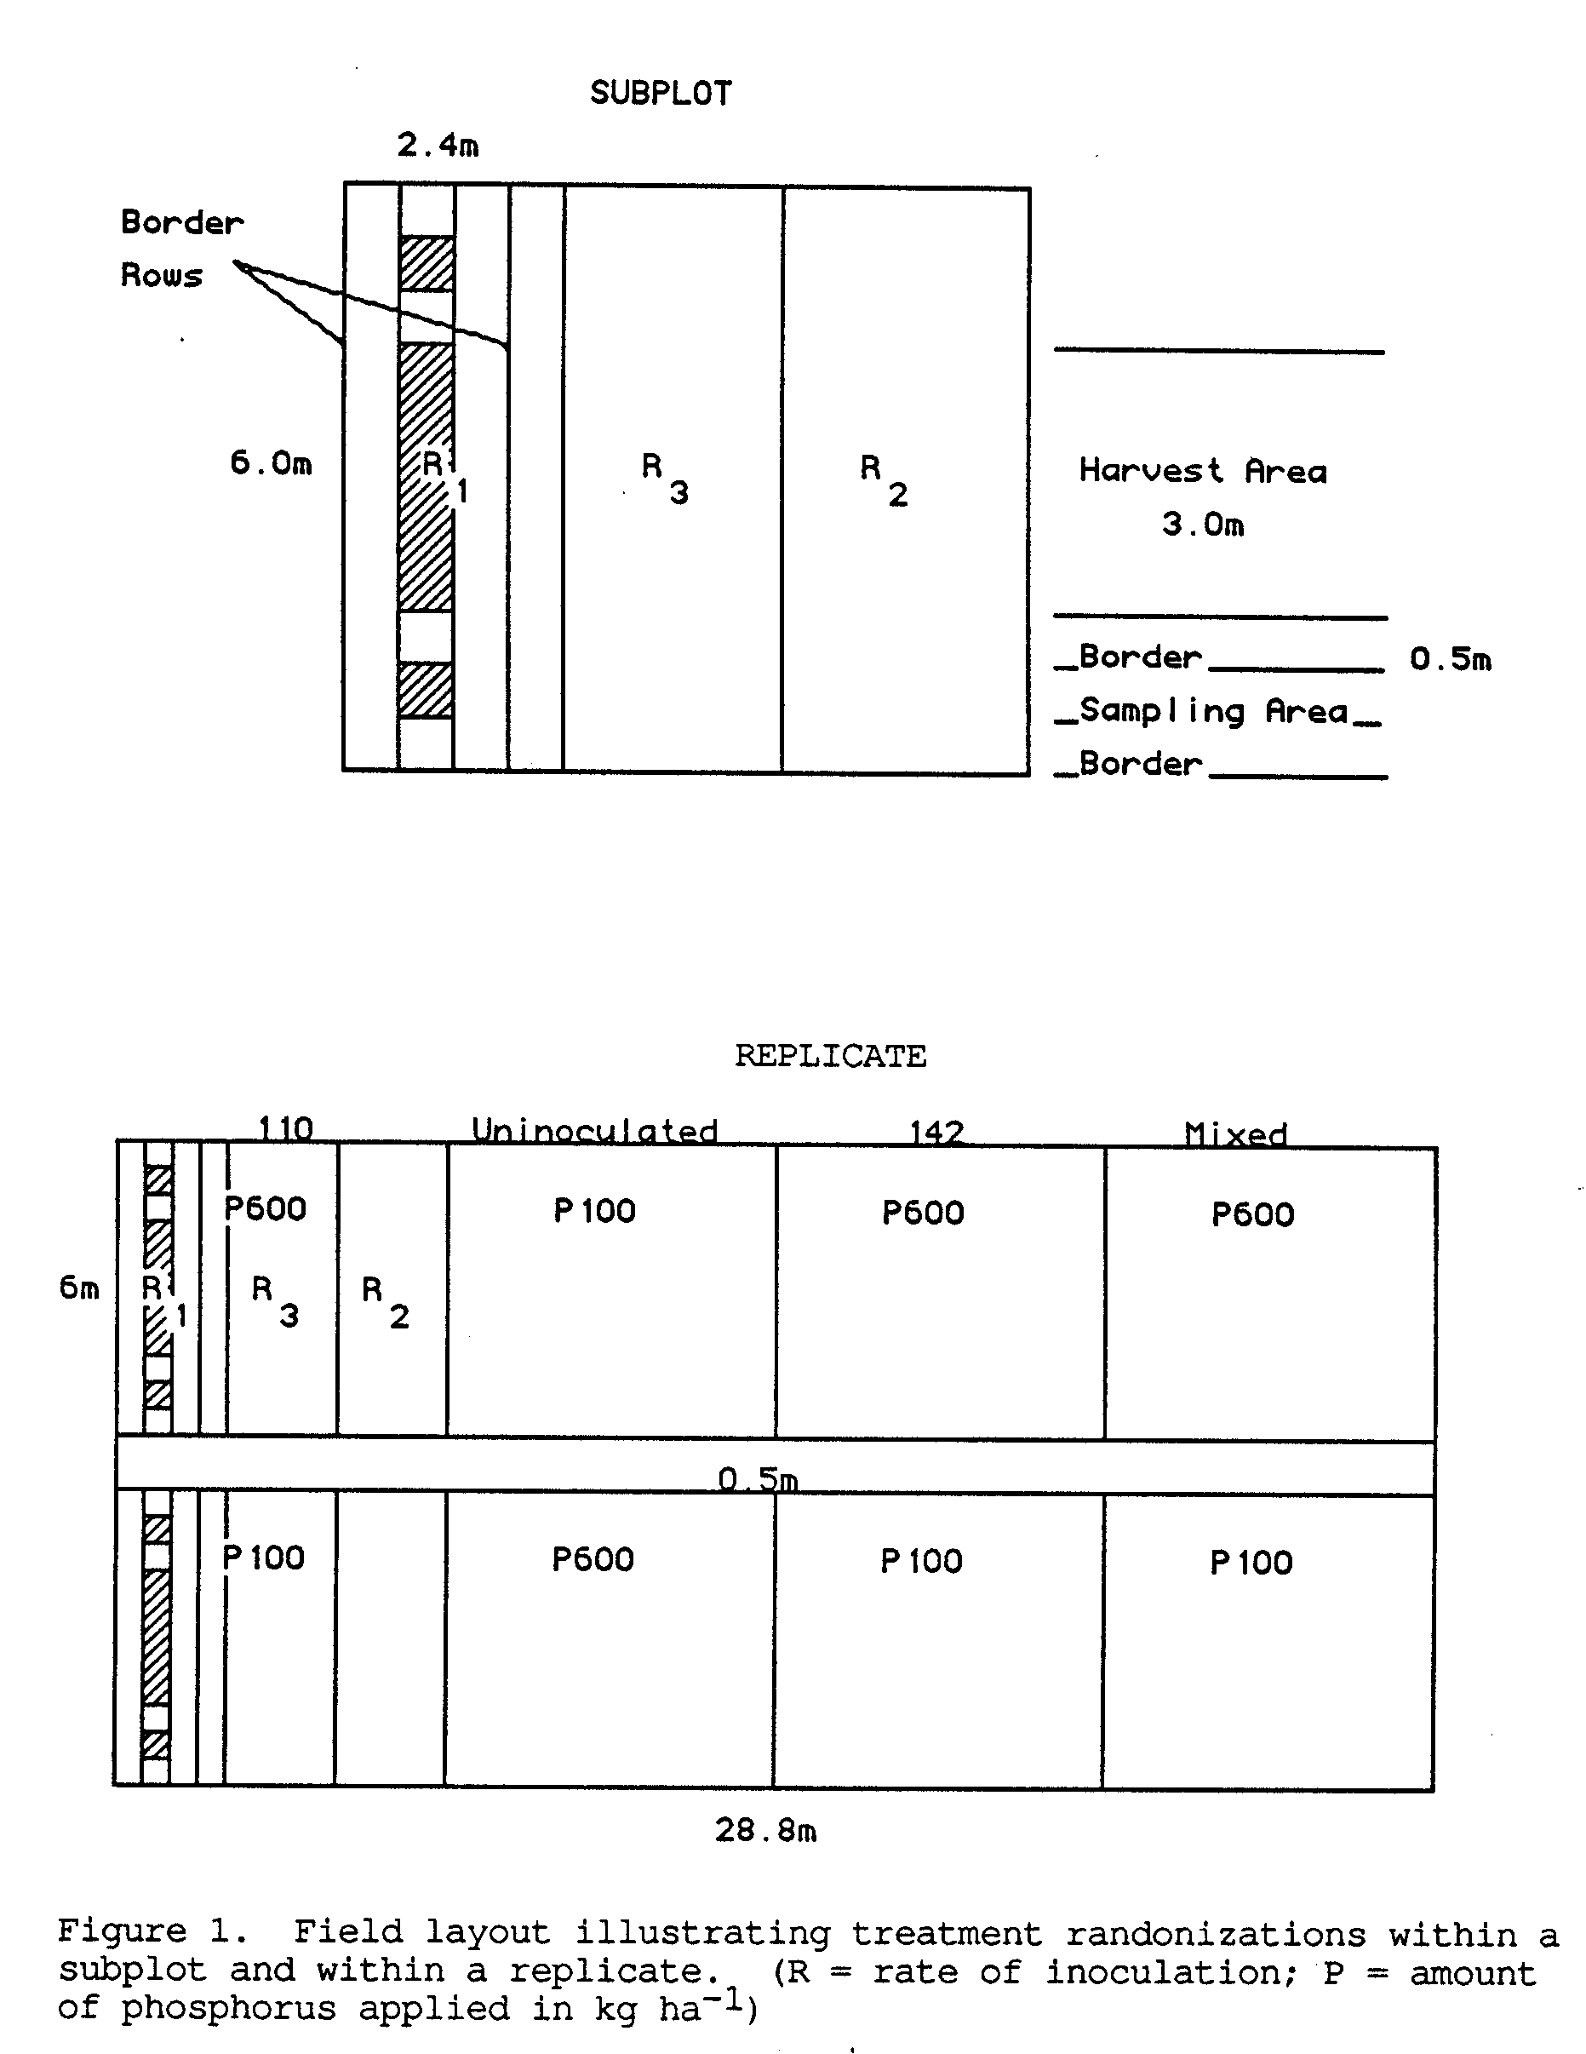
required per sub-subplot to obtain a planting rate of 4 x 10⁵ plants ha⁻¹. Inoculation was done by adding 5.76 g of the appropriate inoculant to each 96.2 g of seed coated with 15% gum arabic solution. This was equivalent to adding 1 g inoculant to 100 seeds, thus, reducing by a 2 log difference the number of rhizobia seed⁻¹ compared to the number per gram of the inoculant used. By using the appropriate inoculant, seed lots were prepared containing 10⁶, 10⁴ and 10² rhizobia cells seed⁻¹. Inoculated seeds were kept under refrigeration for twelve hours before planting.
3.3.3 Planting
Care was taken to maintain viability of the rhizobia on the seed at planting time by keeping inoculated seed in ice boxes until required for planting. In order to prevent contamination, uninoculated seed was planted first and buried before handling other seed. Inoculated seed was planted by strain treatment starting with the lowest inoculation rate. During planting, great care was taken to prevent cross contamination between strain treatments. Each lot of seed (92.6 g) was planted to four rows of a sub-sub plot.
Thermometers and tensiometers were placed randomly across the field to monitor soil temperature and moisture, respectively.
Weeding was done by hand. "Pencap" (Methyl parathion,
300ml in 100L water) was sprayed periodically to control the Chinese
Rose beetle.

3.4 Sample Harvest and Tissue Analysis
Samples were collected at 50% flowering and at physiological maturity.
3.4.1 Sample collection at 50% flowering
Plants from a total of 3 m of the harvest area in each sub-subplot were cut off at the soil line and the combined fresh weight recorded immediately. A sub-sample of 15 plants selected at random was taken from each sub-sub plot for determination of percent moisture. Sub-samples were dried at 80oC for 72 hours and then finely ground.
Nodules were collected from 15 roots dug up at random in the harvest area of each sub-sub plot and number of plants per m² were determined. Roots were carefully washed free of soil and placement of the nodules was recorded. Nodules from each 15-root sample were picked, washed free of soil, and then dried at 60ºC for 48 hours. After drying, nodule samples were weighed and the number of nodules in each sample was recorded. Nodules produced by plants inoculated with the mixed inoculum were identified by the direct fluorescent antibody technique (Somasegaran et al., 1983; Somasegaran and Hoben, 1985) to determine nodule occupancy by the two test strains.
3.4.2 Sample collection at physiological maturity
Plant samples were harvested as at 50% flowering. The exception was that the samples were collected from a total of 6 m row of the harvest area in the sub-subplot.
After total dry matter had been recorded the seed was separated, weighed, and the moisture content determined (Borrows Digital Moisture Computer 700).
3.4.3 Tissue analysis
The finely ground tissue and seed samples were submitted to the Agricultural Diagnostic Services Center, (University of Hawaii), for determination of nitrogen and phosphorus content. For nitrogen determination, the plant samples were prepared by microkjeldahl digestion and analysed colorimetrically (indophenol reaction) by autoanalysis. Plant phosphorus content was determined by Xray fluorescence, (Applied Research Laboratories VSQ, 72000).

3.5 Data Analysis
Analysis of variance and regression analysis were done using the GLM procedure in the SAS program. Means were compared by calculating the L.S.D. using the error mean square from the analysis of variance. Graphs were drawn by the regression procedure in SASGraph.

3.6 Experimental Design
Fourteen treatments were randomized in a split-split block design with 4 replications. Strain comprised the main plot, phosphorus the subplot and inoculation rate the sub-subplot (Figure 1)
IV. RESULTS

4.1 Effect of Strain of Rhizobium, Phosphorus Applied, and
Inoculation Rate on Nodulation at 50% Flowering
The analysis of variance is shown in Table 1. Nodule dry matter was very highly correlated (R² = 0.96) with number of nodules (Fig. 2.).

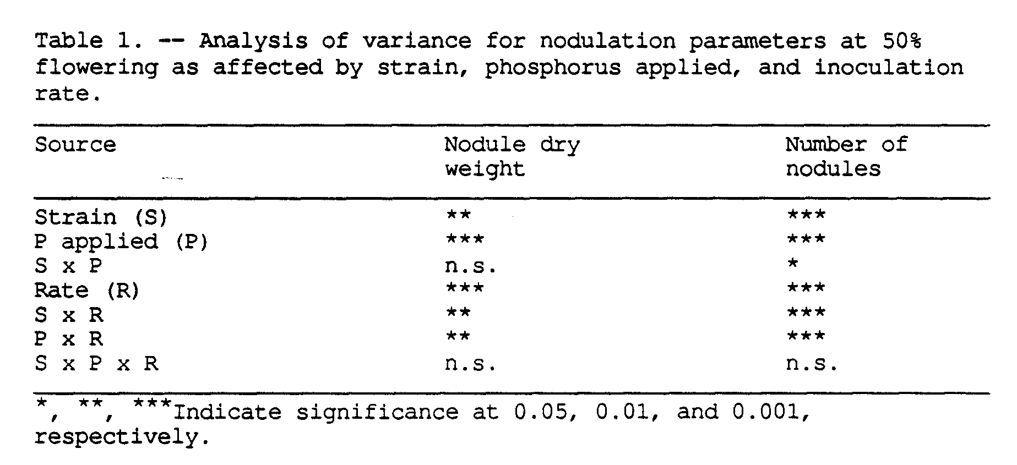

4.1.1 Effect of the interaction between strain and inoculation
rate on nodule dry matter
Total nodule dry matter generally increased with inoculation rate (Fig. 3). Averaged over inoculums and both levels of phosphorus, the highest inoculation rate ( 10⁶ rhizobia seed⁻¹) caused a fivefold increase over the moderate rate (10⁴ rhizobia seed⁻¹), and tenfold increase over the lowest rate (10² rhizobia seed⁻¹).

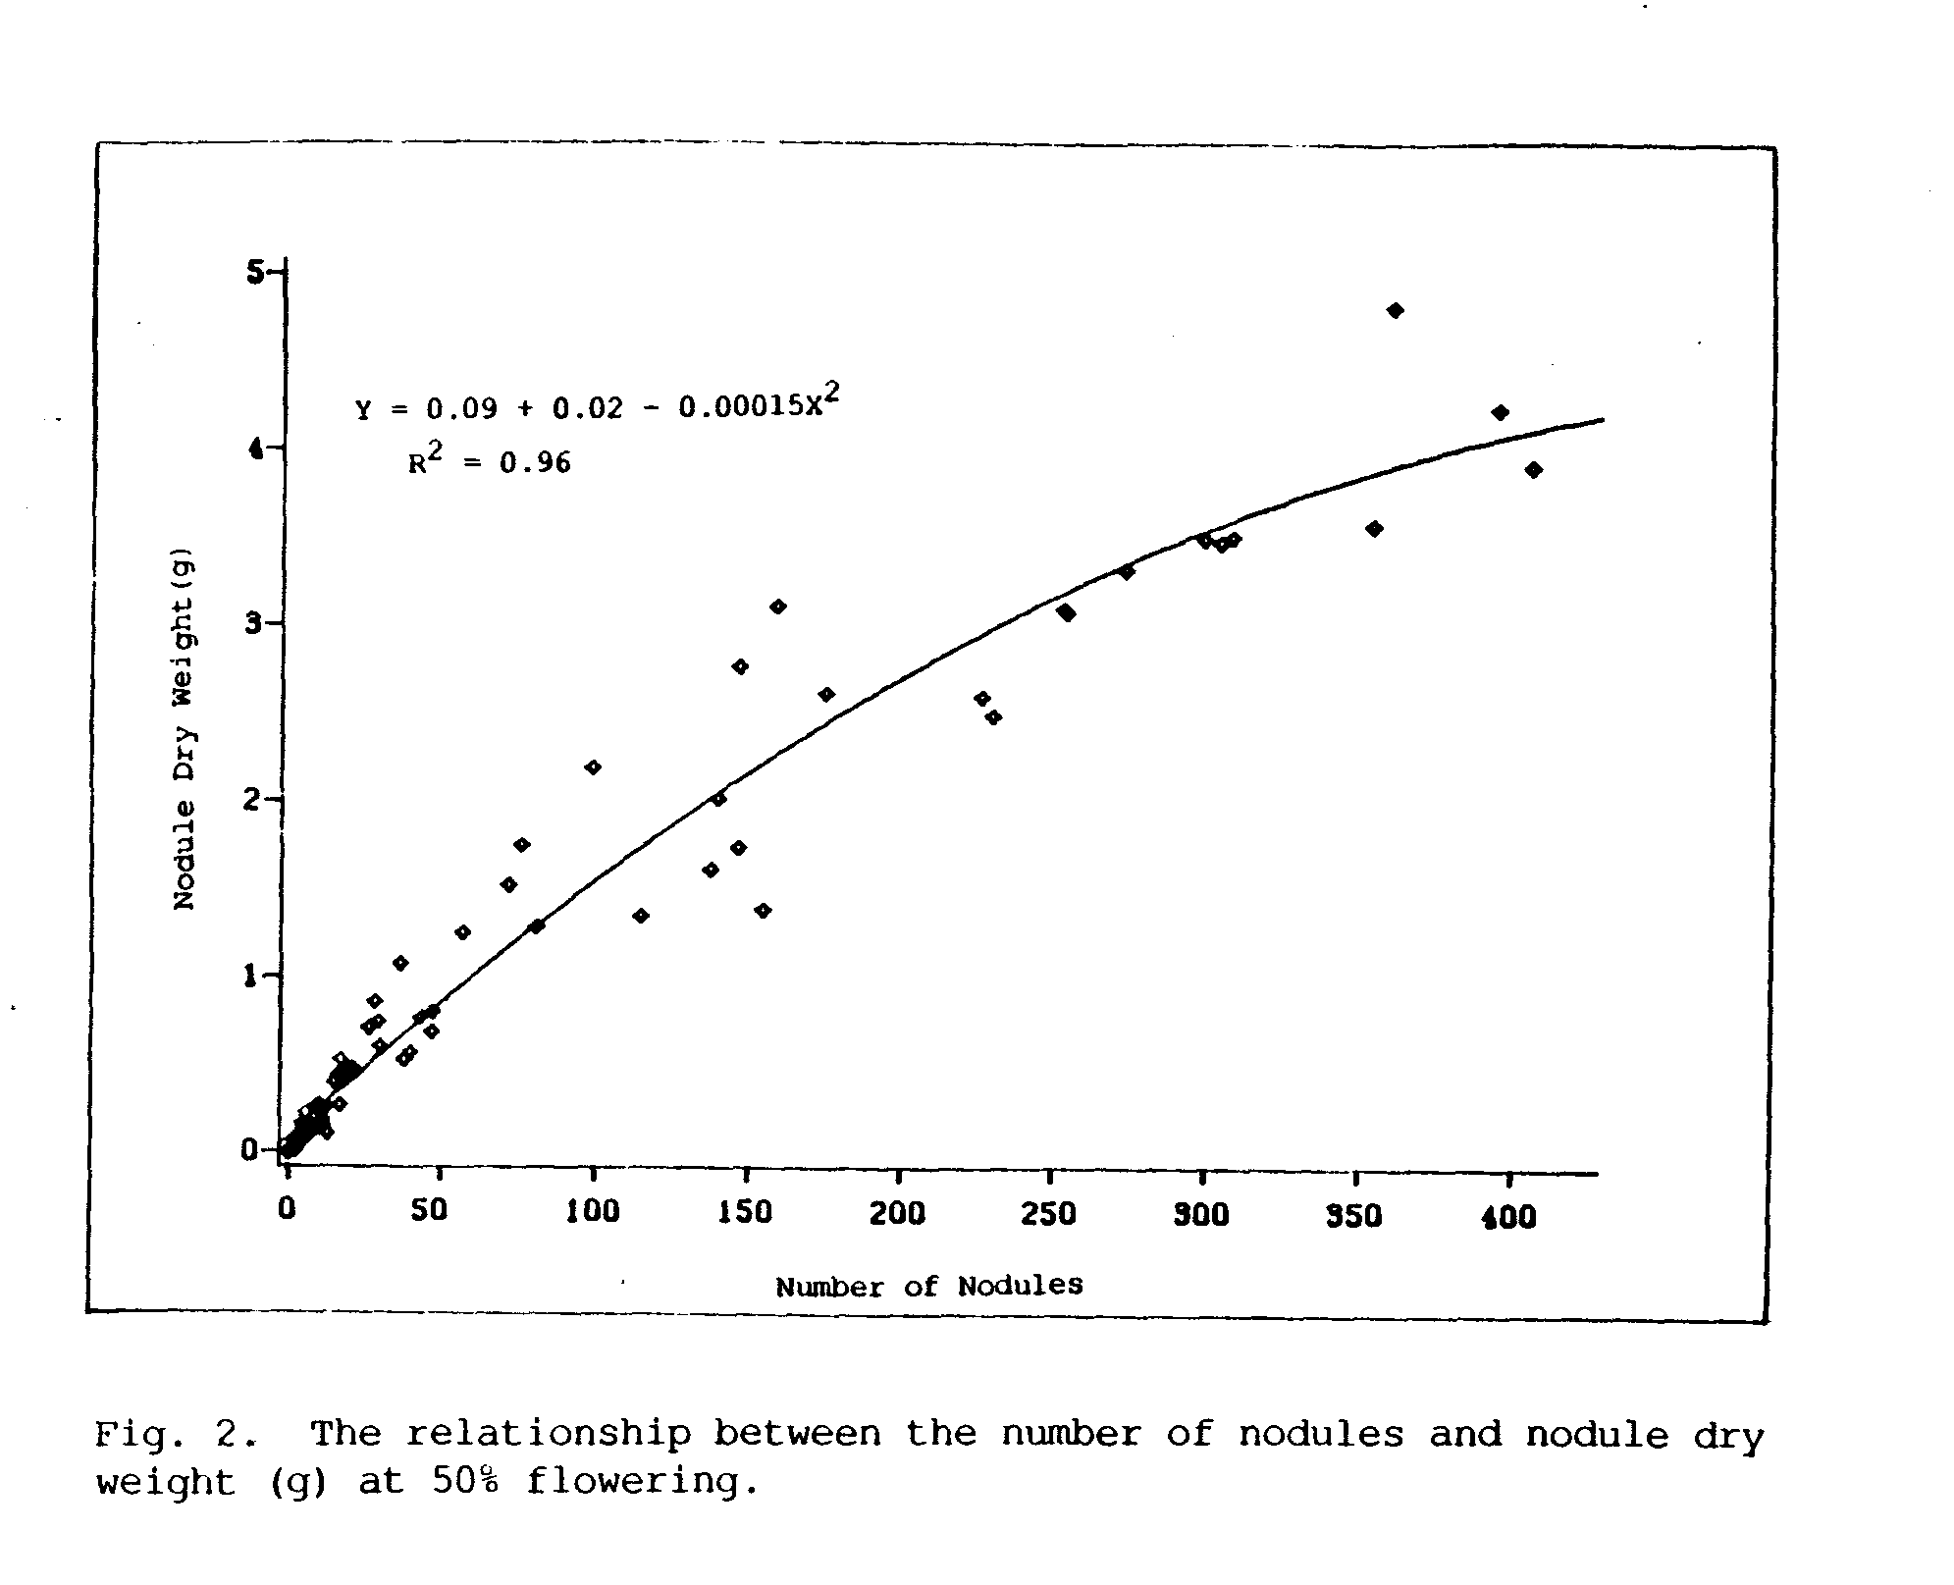

When the inoculation rate was low to moderate (102 to 104 rhizobia seed⁻¹) more nodule dry matter was produced by strain USDA 142 than USDA 110 and the latter outyielded the mixed inoculum, although the differences were not significant. In addition only USDA 142 caused a significant increase in nodule dry matter by plants inoculated at 10⁴ rhizobia seed⁻¹ compared with 102 rhizobia seed⁻¹. However, at the highest rate of inoculation, strain USDA 110 had greater nodule dry weight than strain USDA 142 and the latter nodulated significantly better than the mixed inoculum. At all rates of inoculation, the mixed strain produced the least nodule dry weight.
4.1.2 Effect of the interaction between phosphorus applied and inoculation rate on nodule dry matter
The effect of inoculation rate on nodule dry matter was greatly affected by phosphorus fertility (Fig. 4). There was no significant effect of phosphorus fertilization at the lowest rate of inoculation (10² rhizobia seed⁻¹). However, plants inoculated with 10⁴ and 10⁶ rhizobia seed⁻¹, respectively, had significantly higher nodule dry mass when fertilized with 600 kg P ha⁻¹ compared to plants fertilized with 100 kg P ha⁻¹. Averaged over all strains and rates of inoculation, there was an 83% increase in dry matter due to phosphorus fertilization.
4.1.3 Main effect of inoculation rate on the average weight of a nodule
Nodule dry weight was highly correlated with nodule number (r = 0.98). Regression of weight on number (Fig. 2) showed that the relationship was nonlinear. The average weight of a nodule was

significantly reduced as the rate of inoculation increased (Table 2). At 10⁻² rhizobia seed⁻¹, the average weight of the nodule was 24 mg compared to 13.8 mg at the highest level of inoculation.

4.1.5 Nodule identification
Identification of the nodules formed by the mixed inoculum (Table 8, Appendix A) showed that the proportion of nodules formed by strain USDA 110 was equal to the proportion of nodules formed by strain USDA 142 irrespective of level of phosphorus applied or inoculation rate. There was a tendency for USDA 142 to occupy more nodules at the lowest inoculation rate (102 rhizobia seed⁻¹), (Table 9, Appendix A).
4.1.6 Nodule placement
Nodules formed by plants inoculated with 10⁶ rhizobia seed⁻¹ were aggregated around the tap root while those formed by lower inoculation treatments (10², 10⁴ rhizobia seed⁻¹) were located on the lateral root.

4.2 Main Effects of Phosphorus Applied and Inoculation Rate on Plant Growth Parameters at 50% Flowering
Depending on rate of inoculation, plants were either visibly nitrogen sufficient (leaves large in size and dark green in color) or visibly nitrogen deficient (leaves smaller in size and pale green to yellow in color). Plants grown at high phosphorus (600 kg ha⁻¹) were taller in height compared to plants grown at low phosphorus (100 kg ha⁻¹). Within either level of phosporus application differences in leaf color were more visible than plant height.
The main effects of phosphorus and inoculation rate were highly significant but operated independently of each other (Table 3).
4.2.1 Main effects of phosphorus applied on plant growth
Plants supplied with 600 kg P ha⁻¹ produced 36.8 more dry matter than fertilized with 100 kg P ha^{-l} (Table 4). Tissue analysis showed that plants grown at the higher level of phosphorus application (600 kg ha⁻¹) had accumulated 28.0% more nitrogen, and 42.8% more phosphorus in the shoot than plants at low phosphorus.
4.2.2 Main effects of inoculation rate on plant growth parameters
Differences in shoot dry matter (Fig. 5), shoot nitrogen (Fig. 6), and shoot phosphorus (Fig. 7) between the uninoculated control and the two lower rates of inoculation (10² and 10⁴ rhizobia cells seed⁻¹) were not significant. Compared to the uninoculated

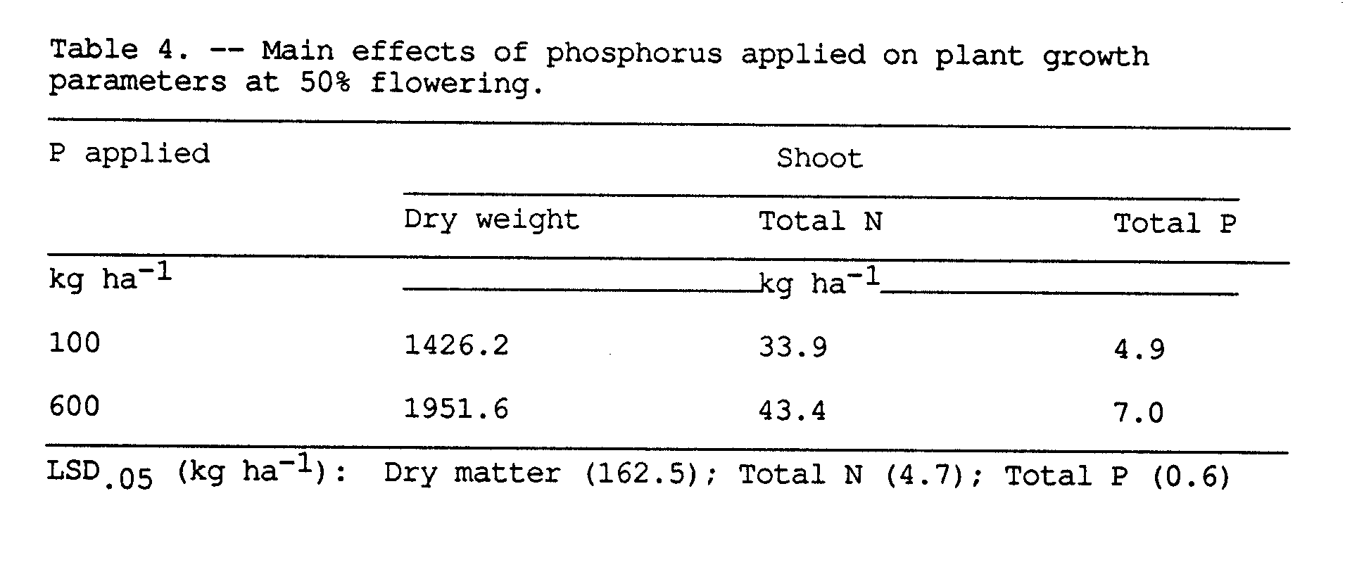

control, the highest inoculation rate (10⁶ rhizobia cells seed⁻¹) significantly increased shoot dry weight by 9.6%, total shoot nitrogen by 36.0, and total shoot phosphorus by 8.5%.
4.2.3 Effect of the interaction between strain and inoculation rate on concentration of nitrogen in the shoot
With all strain treatments, the concentration of nitrogen in the shoot increased consistently from 21 mg N kg^{-l} in plants inoculated with 10² rhizobia seed⁻¹ to 22 mg N kg⁻¹ in plants inoculated with 10⁴ rhizobia seed⁻¹ (Table 5). However, the difference in shoot nitrogen concentration between the low and moderate inoculation rates (10², 10⁴ rhizobia seed⁻¹) were not significant. Concentration of nitrogen in the shoot was significantly greater at the highest inoculation rate (10⁶ rhizobia seed⁻¹) compared to the low and moderate inoculation rates (10², and 10⁴ rhizobia seed⁻¹).

At the highest inoculation rate, plants inoculated with single strain treatments (either USDA 110 or USDA 142) had significantly higher concentration of nitrogen in the shoot (27.5 mg N kg⁻¹) than plants inoculated with the double-strain inoculum (2.4 mg N kg⁻¹).

4.3 Effects of Phosphorus Applied and Inoculation Rate on Plant
Growth at Physiological Maturity
At physiological maturity, leaves and pods in nitrogen deficient plots (uninoculated, 102, 104 rhizobia seed⁻¹) had turned yellow and the leaves were beginning to fall. In plots which had received 10⁶ rhizobia seed⁻¹, leaves in the top half of the plants were still green.
The main effects of phosphorus and inoculation rate were very highly significant but operated independently. There was a high to highly significant effect of interaction between inoculum treatment and phosphorus on dry matter and nitrogen yield (Table 6).
4.3.1 Main effects of inoculation rate on plant growth
parameters
Regression analysis showed that total dry matter and seed yield increased with inoculation rate (Fig. 8). Total dry matter was significantly increased by 23, 52, and 92% over the uninoculated control when plants were inoculated with 10², 10⁴, and 10⁶ rhizobia seed⁻¹, respectively. This trend shows that the percent increase in total dry weight approximately doubled with each inoculation rate.

Increases in seed yield (Fig. 8), total amount of nitrogen accumulated (Fig. 9), and total phosphorus uptake (Fig. 10) followed a trend similar to that of total dry matter with the largest increases occurring at the highest inoculation rate. Seed yield was increased by 20, 56, and 123 and total nitrogen by 32, 79, and 171 over the uninoculated control when plants were inoculated with 10², 10⁴, and 10⁶ rhizobia seed⁻¹, respectively.
The total amount of phospohrus taken up was significantly higher in plants inoculated with 10⁴ and 10⁶ rhizobia seed⁻¹ compared to plants inoculated with 10² rhizobia seed⁻¹. There was no significant difference in phosphorus uptake between the latter and uninoculated plants. The general trend was for phosphorus content to increase with inoculation rate.

4.3.2 Effects of the interaction between strain and phosphorus applied on plant growth parameters
4.3.2.1 Dry matter
There was no significant effect of phosphorus application on total dry weight when plants were not inoculated. With all inoculated treatments total dry matter was significantly greater at high phosphorus (600 kg ha⁻¹) than at low phosphorus (100 kg ha⁻¹), but the magnitude of increase varied with strain treatment (Fig. 11).

Inoculation with strain USDA 142 resulted in the greatest response to increased phosphorus application with 49.4 increase in yield. Inoculation with either strain USDA 110 or the mixed inoculum caused a smaller but significant 18.3 increase in yield with high phosphorus application.
Within levels of phosphorus applied inoculated treatments yielded significantly higher than the uninoculated control. At 100 kg P ha⁻¹ differences in yield among inoculated treatments were not significant. At 600 kg P ha^{-l} strain USDA 142 outyielded both strain USDA 110 and the mixed strain treatment by at least 28%.
4.3.2.2 Seed yield (13% moisture)
Response to application of phosphorus was significant although the magnitude varied among mainplot treatments (Fig. 12).
Strain USDA 142 caused the highest increase in yield (57.2) at high phosphorus (600 kg ha⁻¹) over low phosphorus (100 kg ha⁻¹). By comparison the yield increases caused by inoculation with strain USDA 110 or the mixed inoculum were only 17.2 and 14.7, respectively.
The differences in seed yield among inoculated treatments at 100 kg P ha^{-l} were not significant, but at 600 kg P ha⁻¹, inoculation with USDA 142 yielded 36% more seed than inoculation with USDA 110 which yielded 31% more than the mixed inoculum. Within either level of applied phosphorus, yields of inoculated treatments were significantly greater than that of the uninoculated control.
4.3.2.3 Total nitrogen
The effect, of level of phosphorus applied on total nitrogen accumulated (Fig. 13) was similar to that for total dry
matter response. Within each mainplot treatment plants fertilized with 600 kg P ha^{-l} accumulated significantly more nitrogen than plants provided 100 kg P ha⁻¹. However, the magnitude of response to increased phosphorus fertilization varied with the strain. Inoculation with strain USDA 142 resulted in the greatest increase (69.2%) followed by strain USDA 110 (17.3%), and the mixed inoculum (13.5%) having the least increase in total nitrogen. Uninoculated plants gained a significant 35% increase in nitrogen content due to increased phosphorus application.
Within either level of applied phosphorus inoculated plants had significantly greater total nitrogen compared to uninoculated plants. At 100 kg P ha⁻¹ the difference between inoculation with UDSA 110 and inoculation with USDA 142 was not significant but inoculation with strain USDA 142 resulted in 23% increase over plants inoculated with the mixed inoculum. At 600 kg P ha⁻¹ all inoculation treatments differed significantly from each other in terms of total nitrogen; USDA 142 yielded 52% more than USDA 110 which yielded 20% more than the mixed inoculum.
4.3.2.4 Plant P uptake
Plants fertilized with 600 kg P ha^{-l} had 31.9 and 38% more total P and seed P, respectively, than those fertilized with 100 kg P ha⁻¹ (Table 7).

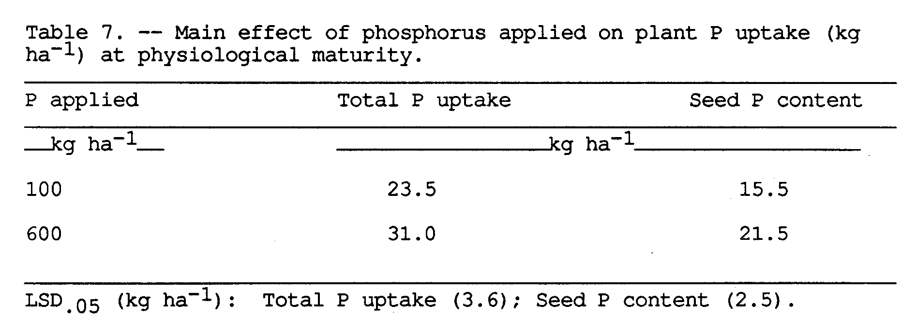

4.3.2.5 Harvest index
The harvest index was significantly increased at high inoculation rate (0.49) compared to low rates of inoculation (0.43).
Phosphorus fertilization had no influence on the harvest index (Table 10, Appendix B)

V. DISCUSSION

Soybean is a new crop in the tropics and the strains of Rhizobium japonicum required for effective nodulation are generally not present among the naturalized population of rhizobia in the soil. The immediate solution to this problem is to introduce effective strains by inoculation. However, introduced strains are not always well adapted to new soil environments such as acidity, elevated temperatures, and competition from naturalized rhizobia. Under suboptimal conditions nodulation performance of an introduced strain may be improved simply by high rates of inoculation (Burton, 1976; Kvien et al., 1985). However, facilities for producing high quality inoculums are not always available in developing countries. When the quality of the inoculum being used is low it is difficult to introduce high numbers of the required strain by conventional methods of seed inoculation. A possible solution to this problem may be to introduce strains able to survive suboptimal conditions and cause effective nodulation even when inoculation is inadequate.
Two strains of R. japonicum were used in the present experiment. Previous reports have indicated that the growth rate of one of the strains (USDA 142) was reduced when the concentration of phosphorus in the growth medium was low, whereas the other strain (USDA 110) grew well irrespective of phosphorus concentration.
The objective of the experiment was to determine whether tolerance to phosphorus concentration by strain USDA 110 translated into increased nodulation and plant growth when soybeans were grown in soil that had high phosphorus sorption capacity and when inoculation was inadequate.

5.1 Nodulation
Nodule dry matter was very highly correlated with number of nodules indicating that nodule dry weight increased as the number of nodules increased (Fig. 2), and that either one of the parameters could be used as an index to asses treatment effects on nodulation. However, the results in Table 2 also show that the average weight of a nodule decreased as the number of nodules increased which explains why nodule dry weight did not increase linearly with nodule number. As indeces of nodulation nodule dry matter is the more reliable since amount of nitrogen fixed depends on nodule mass rather than nodule number.
Nodule dry matter produced by uninoculated plants was insignificant compared to that of inoculated treatments. The performance of the inoculum strains was, therefore, not affected by potential competition from naturalized strains making it possible to observe the actual nodulation response to inoculation at the various rates.
Statistical analysis of results from nodule identification indicated that there was no significant difference in the proportion of nodules occupied by strains USDA 110 and USDA 142, respectively, irrespective of amount of phosphorus applied or rate of inoculation (Table 8, Appendix A). Seemingly, the test strains were similarly affected by experimental conditions and equally competitive in the rhizosphere. Although statistically insignificant there was a tendency for more nodules to be occupied by strain USDA 142 than by USDA 110 at rate 10² rhizobia seed⁻¹ with both levels of phosphorus application (Table 9, Appendix A). Clearly strain USDA 110 did not survive any better than USDA 142 at low phosphorus application and inoculation.
5.1.1 Nodule placement
It has been reported that placement of nodules on the host root can be used as a qualitative indicator of the adequacy of inoculation. Results in this experiment showed that nodules of plants inoculated at high rate (10⁶ rhizobia seed⁻¹) tended to be aggregated on the tap root whereas nodules formed by plants with low inoculation rates were mostly located on lateral roots. This observation agrees with the results reported by Weaver et al. (1972). According to Burton (1976) the placement of nodules on the root system is also an indication of the earliness of nodulation. Seemingly a large population of rhizobia must be present when the radicle emerges in order for the tap root to be effectively infected. Thus, adequately inoculated plants have the advantage of nodulating and fixing nitrogen much earlier than when inoculation rates are low to moderate. This may be the reason why tap root nodulation is considered more effective than nodulation on the lateral roots.
5.1.2 Effect of inoculation rate
Regression analysis showed that inoculation rate was responsible for a larger proportion of the variation in nodule dry matter than either phosphorus applied or strain treatment (Table 11, Appendix C). Although very much smaller than inoculation rate, effects of inoculum treatments and phosphorus were highly significant, as was also found with yield response. Percentage of increase in nodule dry weight doubled with each inoculation rate indicating that the chance of root infection occurring greatly improved as the population of rhizobia in the rhizosphere increased.
The effect of inoculation rate varied significantly among strain treatments. Inoculation with USDA 142 was the only treatment which increased nodule dry matter with each inoculation rate. At low to moderate inoculation rates (10², 10⁴ rhizobia seed⁻¹), USDA 142 had greater nodule dry matter than USDA 110 although differences were not significant. When the two strains were mixed there was also an indication that USDA 142 might have occupied more nodules than USDA 110 when the inoculation rate was 10² rhizobia seed⁻¹ (Table 9, Appendix A). Apparently USDA 142 survived low inoculation rates better than USDA 110. With USDA 110 and the mixed inoculum, increasing the inoculation rate to 10⁴ rhizobia seed⁻¹ did not significantly increase nodule dry matter over 10² rhizobia seed⁻¹ although the number of nodules was increased. This lack of response may be attributed to the compensating mechanism reported by Singleton et al. (1983). The mechanism apparently enables the soybean plant to obtain maximum nitrogen fixation from the number of nodules present so that, within limits, increase in number of nodules does not result in increased nitrogen fixation.
5.1.3 effect of phosphorus fertilization
There was a highly positive interaction between phosphorus application, inoculation rate, and nodule dry matter. Generally, nodule dry matter increased with phosphorus application and inoculation rate although the difference between phosphorus levels was not significant at the lowest inoculation rate (10² rhizobia seed⁻¹). This effect of phosphorus on nodulation has been previously observed (Bonetti et al., 1984; Singleton et al., 1985), and has been attributed to the greater partitioning of root dry matter into nodule tissue when the phosphorus supply is adequate (Cassman et al., 1980). The presence of more phosphorus was found to stimulate early development of nodule tissue which contributed not only to earlier onset of nitrogen fixation but also to longer functioning of the nodules (Bonetti et al., 1984). Results of the present experiment show that nodulation can be improved by high inoculation even when phosphorus is low but maximum benefit can only be obtained when both phosphorus applied and inoculation are adequate.
One of the objectives of the experiment was to observe whether in vitro tolerance to low phosphorus concentration by a strain of Rhizobium was of agronomic significance. It has been reported that colonization of the rhizosphere and nodule initiation are dependent on the rate of growth of an introduced strain (Dart, 1977). Since the concentration of phosphorus in the rhizosphere is much less than 1.0 uM, Cassman et al. (1981) and Beck and Munns (1984) suggested that colonization of a legume root rhizosphere might be improved by selecting strains able to utilize low levels of phosphorus. Tolerance of a strain to low phosphorus would be particularly useful in soil that has high phosphorus sorption capacity, especially, when inoculation is inadequate. Findings of the present experiment did not show any effect of interaction between strain and phosphorus on nodule dry matter (Table 1). When the rate of inoculation was low strain USDA 142 nodulated just as well as USDA 110. There was, therefore, no correlation between phosphorus tolerance and the effectiveness of a strain. It seems that selecting Rhizobium strains on the basis of their in vitro tolerance to phosphorus may be a poor substitute for actually testing the effectiveness of strains under field conditions.

5.2 Plant Growth and Accumulation of Nitrogen and Phosphorus
5.2.1 50% flowering stage
At 50% flowering the soybean plants exhibited visually effects of both phosphorus fertilization and inoculation rate. Response to phosphorus was seen by the shorter height of plants grown at low phosphorus (100 Kg ha⁻¹) compared to the height of plants at high phosphorus (600 Kg ha⁻¹). Response to inoculation was visible by the more vigorous growth habit and dark green color of plants treated with 10⁶ rhizobia seed⁻¹ irrespective of strain and phosphorus fertilization. Plants inoculated with 10⁴ rhizobia seed⁻¹ were a little greener than plants inoculated with 10² rhizobia seed⁻¹ but both treatments were obviously nitrogen deficient.
Total-plant samples were taken to quantitatively determine early effects of the treatments on plant growth. The analysis of variance showed no significant effect of interactions between the various treatments on shoot dry matter, shoot nitrogen or shoot phosphorus (Table 3). Correlation coefficients in Table 12, Appendix C indicate that, up to flowering stage, shoot dry matter and phosphorus uptake were affected more by phosphorus applied than inoculation. This is further indicated by the fact that there was a greater increase in dry matter due to phosphorus applied (36.8%) than inoculation rate (9.6%). This finding is not surprising because maximum nodulation is not reached until about flowering stage or thereafter (Brockwell et al., 1982) and, therefore, the growing plants would still be largely dependent on soil nitrogen unless effective nitrogen fixation had started earlier, as was the case with plants treated with the highest inoculation rate (10⁶ rhizobia seed⁻¹).
The visible leaf color differences among inoculation rates corresponded with differences in nodule dry weight, shoot dry matter, shoot nitrogen, shoot phosphorus, and concentration of nitrogen in the shoot. With all these growth parameters, response to inoculation at 10⁶ rhizobia seed⁻¹ was highly significantly greater than lower inoculation rates (10² and 10⁴ rhizobia seed⁻¹) indicating that nitrogen supply had already started to influence plant growth. The main effect of phosphorus application on yield was significant. Dry matter, nitrogen, and phosphorus accumulation in the shoot were greater at the higher level of phosphorus (600 Kg ha⁻¹). There was no phosphorus x inoculation rate interaction which means that unlike nodule dry matter, the effect of inoculation on plant growth was not greatly influenced by amount of phosphorus applied obviously because phosphorus had had greater influence on dry matter accumulation.
Shoot dry weight, shoot nitrogen, and total phosphorus content of plants that were inadequately nodulated (10² and 10⁴ rhizobia seed⁻¹) were not significantly different from the uninoculated control indicating that inadequately nodulated plants were still dependent on nitrogen from the soil the availability of which increased with level of phosphorus applied (Table 4).
5.2.2 Physiological maturity staff
Unlike the early stage of growth (50% flowering), relative effects of the strain treatments on growth parameters were clearly distinguished at physiological maturity. Burton (1976) recommended that nitrogen fixing effectiveness of a Rhizobium strain can best be determined by growing the plants to maturity to create the maximum nitrogen stress. Findings of the present experiment agree with this suggestion because the relative values of correlation coefficients for level of phosphorus applied and inoculation rate show that plant growth, in terms of total dry matter and seed yield, became more dependent on nitrogen supply as maturity approached (Table 13, Appendix C).
The positive effect of inoculation was indicated by the fact that all inoculated treatments accumulated greater dry matter, total nitrogen, total phosphorus, and had higher seed yield than the uninoculated control. It was observed earlier that at 50% flowering there was no significant difference in dry matter yield between uninoculated plants and those inoculated with 10² and 10⁴ rhizobia seed⁻¹. The relative amount of nitrogen accumulated was probably the greatest factor which ultimately made the difference in yield among these treatments as maturity approached. Differences in yield response among rates of inoculation are shown in Figs. 8, 9 and 10. Total dry matter, total nitrogen and seed yield were highly correlated (Table 15, Appendix C). Furthermore, correlation coefficients indicate that inoculation rate explained a greater proportion of the variation in these yields than either the strain or level of phosphorus applied (Table 13, Appendix C). It is clear that dry matter, total nitrogen, and seed yield were all reliable indices for assessing adequacy of inoculation.
The economic end product of soybean production is seed. Seed yield is dependent on the amount of carbohydrate and nutrients that are translocated from the vegetative to reproductive parts of the plant during growth. Findings by Kollman (1974) did indicate that the amount of carbohydrate translocated from the vegetative part of soybean increased with the size of the reproductive sink, which is a function of the relative growth rate of the plant. Findings of the present experiment demonstrated that the harvest index (Table 10, Appendix B) was significantly increased by the highest rate of inoculation indicating that more dry matter was converted into seed when plants were adequately supplied with nitrogen. Concentration of nitrogen in the seed was higher for inoculated plants compared to uninoculated plants. Seed produced by uninoculated plants contained 4.8% nitrogen which was increased to 5.9% by inoculating with 10⁶ rhizobia seed⁻¹. The difference would probably have been greater had plants at high inoculation been grown to full maturity because, at harvest, top parts of plants in this treatment were still dark green indicating that nitrogen was still being translocated to the pods. Concentration of nitrogen paralleled the variation in total seed nitrogen. Therefore, the amount of nitrogen supplied at different inoculation rates had a direct effect on the quality of seed in terms of protein content.
Effects of strain x rate, and phosphorus x rate interactions were not significant on any growth parameter showing that response to inoculation rate was affected neither by strain treatment nor level of phosphorus applied. Total dry matter, seed yield, nitrogen and phosphorus accumulated significantly increased with inoculation rate (Fig. 8, 9 and 10). Since the main effect of phosphorus on these parameters was also highly significant (P = 0.001), and there was no interaction between the two treatments it can be concluded that the effects of phosphorus and inoculation rate were independent of each other. This conclusion is supported by the fact that, with strain USDA 110 and the mixed inoculum, total nitrogen at high phosphorus was not very much higher than at low phosphorus. It can be expected that the effectiveness of strain USDA 142 was greater at high than low phosphorus.
Total phosphorus uptake was significantly greater at the higher rates of inoculation (10⁴ and 10⁶ rhizobia seed⁻¹), which supports the conclusion by white (1973) that the demand for phosphorus created by plant growth probably influences uptake of phosphorus from the soil. This would be beneficial to the symbiotic system because increased nodulation places greater demand for phosphorus in order to maintain nodule tissue and plant growth (Davis 1980) as well as fix atmospheric nitrogen.
All mainplot treatments responded to increased phosphorus fertility but differed significantly from each other in terms of total dry matter, seed yield and total nitrogen (Figs. 11, 12, 13); USDA 142 was clearly superior to USDA 110 and the mixed treatment at the higher level of phosphorus (600 Kg ha⁻¹). At low phosphorus (100 Kg ha⁻¹), strain USDA 142 caused the greater increase in total amount of nitrogen but differences in total dry matter and seed yield were not significant. These results demonstrate that plant growth was limited by nitrogen supply when phosphorus was adequately available and are in agreement with the conclusion by Singleton et al (1985) that; (a) a superior symbiotic system is necessary in order to obtain maximum response to phosphorus, and conversely, (b) greater responses to inoculation can be obtained under conditions of adequate phosphorus fertility.
The respective in vitro tolerance to phosphorus by strains USDA 110 and USDA 142, previously reported by Cassman et al. (1981), was not a factor in the performance of either strain at low phosphorus suggesting that this characteristic of R. japonicum is not a significant at levels of fertilizer phosphorus required to obtain the minimum economic yield of soybean. Rhizobia should be tested under field conditions because symbiotic effectiveness among strains varies. For instance, USDA 110 has been reported to be a very effective strain (Singleton et al., 1985) and it certainly did significantly increase yields over the uninoculated control in the present experiment but strain USDA 142 proved to be more effective when phosphorus was adequate. It is not possible to say whether the amount of nodule dry matter was responsible for the superior performance by strain USDA 142 over USDA 110. According to Dr. R. J. Roughley (personal communication) continued nodulation may occur after the 50% flowering stage, probably depending on the extent to which nodulation is inhibited by soil nitrogen during early stages of plant growth. Therefore, although these data show no significant strain x phosphorus effect on nodule dry matter at 50% flowering, it might not have been the case as physiological maturity approached. What was definite from the results was that strain USDA 142 showed greater sensitivity to high phosphorus availability than USDA 110.
An inoculation rate of at least 10⁶ rhizobia seed⁻¹ was required for effective nodulation at Kuiaha. This rate compares well with findings by Smith et al. (1981) who found that at least 10⁵ rhizobia cm⁻¹ were necessary to establish effective nodulation in an R, japonicum free tropical soil.
It is interesting to note that when strains were mixed, the yields were significantly lowered compared to single strain treatments. The effectiveness of the mixed inoculum relative to single strain treatments was consistent throughout the experiment, which makes the observation important. Further research needs to be done on this aspect of inoculation before conclusions can be drawn because it has important implications on use of mixed-strain inoculums.
VI. SUMMARY AND CONCLUSIONS

A field experiment was conducted in Haiku soil (clayey, ferritic, isohyperthermic Humoxic Tropohumult) previously reported to have high phosphorus sorption capacity.
Treatments were three inoculums ("USDA" 110, 142, mixed 110/142) as mainplots, subplots were two levels of phosphorus (100, 600 Kg P ha⁻¹), and three rates of inoculation (10², 10⁴, 10⁶ rhizobia seed⁻¹) were the sub-subplots. An uninoculated control subplot was established at each level of phosphorus. The partial factorial of 14 treatments were arranged in a split-split plot design.
Experimental objectives were to determine; (a) the relationship between phosphorus fertility, inoculation rate, and nodulation by two strains of Rhizobium japonicum differing in in vitro tolerance to phosphorus concentration, and (b) the interaction between strain of R. japonicum, phosphorus fertility and inoculation rate on nitrogen accumulation and yield of soybeans (Glycine max (L.) Merr. cv. 'Davis').
Results of the experiment showed the following:
(a) When the inoculum was applied in mixed-strain form the proportion of nodules occupied by strain USDA 110 was not greater than occupied by USDA 142, irrespective of level of phosphorus applied or inoculation rate.
(b) Averaged over inoculum treatments and levels of phosphorus, inoculation with 10⁶ rhizobia seed⁻¹ yielded five times more nodule dry matter over 10⁴ rhizobia seed⁻¹ which, in turn, yielded twice as much nodule mass as the lowest inoculation rate.
However, response to inoculation rate was greatly affected by inoculum and phosphorus treatments; At 10⁶ rhizobia seed⁻¹ USDA 110 yielded more nodule mass than USDA 142 which was greater than the mixed inoculum, but there was no significant difference between 10² and 10⁴ rhizobia seed⁻¹ with respect to inoculum treatment or, with the exception of USDA 142, to rate. Thus, USDA 110 did not yield more nodule dry matter than USDA 142 at low inoculation rates (10², 10⁴ rhizobia seed⁻¹), irrespective of level of phosphorus applied.
Over all inoculum treatments, nodule dry matter increased with level of phosphorus application at each inoculation rate but the difference between phosphorus levels was not significant at the lowest inoculation rate (10² rhizobia seed⁻¹). On average high phosphorus application yielded 83% more nodule mass than low phosphorus.
(c) At 50% flowering the greater proportion of the variation in shoot dry matter and phosphorus uptake was due more to level of phosphorus applied than to inoculation.
Compared to the control treatment, high inoculation (10⁶ rhizobia seed⁻¹) increased shoot dry matter, shoot nitrogen, and shoot phosphorus by 9.6, 36.0, and 8.5%, respectively. There was no significant difference between the uninoculated treatment and low inoculation rates (10², 10⁴ rhizobia seed⁻¹).
Plant growth responded positively to increased phosphorus fertilization. Shoot dry matter, shoot nitrogen, and shoot phosphorus increased by 36.8, 28.0, and 42.8%, respectively.
(d) Regression analysis showed that, at physiological maturity, inoculation rate was the more significant factor limiting dry matter accumulation than phosphorus supply. This observation agreed with the fact that dry matter and seed yields were more highly correlated with nitrogen accumulated than with phosphorus uptake.
Inoculum treatments differed significantly in response to phosphorus fertility in terms of total dry matter, seed yield, and total nitrogen; At high phosphorus (600 Kg ha⁻¹), USDA 142 yielded 51.8% more nitrogen than USDA 110 which yielded 20% more than the mixed inoculum. At low phosphorus (100 Kg ha⁻¹) there was no significant difference between USDA 142 and 110 but both treatments yielded significantly higher nitrogen than the mixed inoculum.
Nitrogen yield response to the interaction between inoculum and phosphorus correlated with total dry matter and seed yield response.
A notable effect of the inoculation rate was increased harvest index which shows that more dry matter was converted into seed when nitrogen supply was not limiting.
Conclusions from observations of the experiment are;
(a) Under low phosphorus, neither nodule dry matter nor yield was increased by inoculating with strain USDA 110 compared to USDA 142. In vitro tolerance of R. japonicum to phosphorus concentration is probably of no agronomic significance.
(b) Effective nodulation by soybeans requires adequate inoculation of the seed at planting time. At Kuiaha at least 106 rhizobia seed⁻¹ were necessary.
(c) The effectiveness of adequate inoculation can be improved by selecting, in the field, highly efficient strains of Rhizobium under sufficient phosphorus fertilization.

APPENDIX A
Nodule Occupation by Strains USDA 110 and USDA 142
as Identified from Nodules Produced by Plants
Inoculated with the Mixed-Strain Inoculum
A.1 Nodule Collection and Identification
Plants from 1.5 m of each of two harvest rows were harvested 41 days after germination. 15 plants were selected at random and nodules carefully picked and washed. Nodules were dried in vials at 60º C for 48 hours.
Nodules were identified by the fluorescent antibody technique (Somasegaran et al., 1983; Somasegaran et al., 1985) using antisera TAL 102 FA V and TAL 379 FA V diluted 1:4 with phosphate buffered saline. The antisera were obtained at Niftal Project, University of Hawaii.
All nodules from inoculation rates 10² and 10⁴ were identified while only one-third of nodules from the 10⁶ inoculation treatments were randomly selected and identified.

A.2 Results
Positive reactions from identifications were very clearly bright green under UV light and there was very little interference from background fluorescence. Nodules from dual-strain infections were identified by positive reactions with both antisera. Nodules reacting negatively with both antisera were classified as of unknown (other) origin.
Overall, results showed that 96.7 percent of the nodules formed were occupied by the test strains. Only 3.3 percent of the nodules were occupied by native strains (Table 8). Nodules occupied dually by both test strains were significantly fewer than those occupied singly by either strain. There was no significant difference between proportions of nodules occupied by either strain. There was also no significant effect of either phosphorus or inoculation rate on strain nodule occupancy. Table 9 shows the respective proportions within phosphorus treatments. The proportion of mixed infections were, on the average, higher at the 600 kg P ha^{-l} than at the 100 kg P ha⁻¹. The proportion of unidentified nodules was about 6 percent at both phosphorus levels.

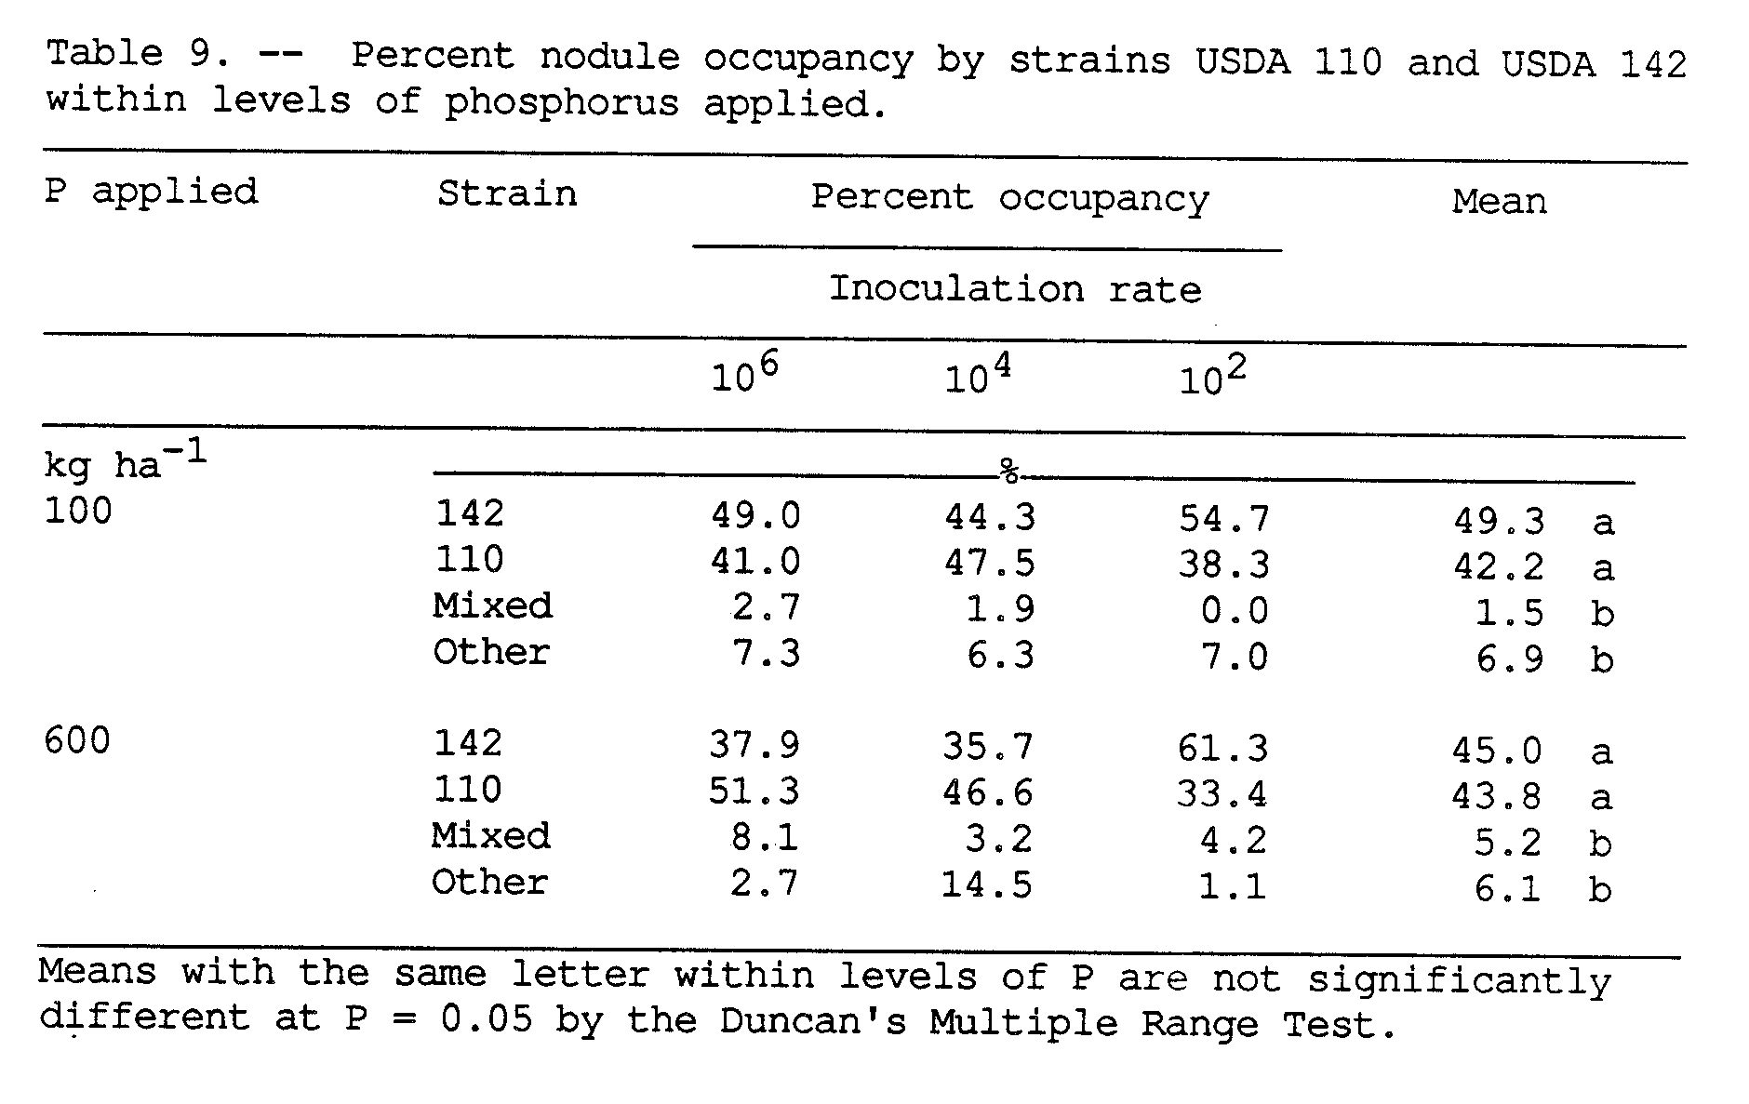

APPENDIX B
Harvest Index as Affected by
Inoculation Rate

APPENDIX C
Regression Equations Relating Soybean Modulation and
Growth Parameters at Flowering and Maturity
to Strain, Phosphorus, and Inoculation Rate;
Correlation Coefficients among Plant Growth Parameters
at Flowering and Maturity

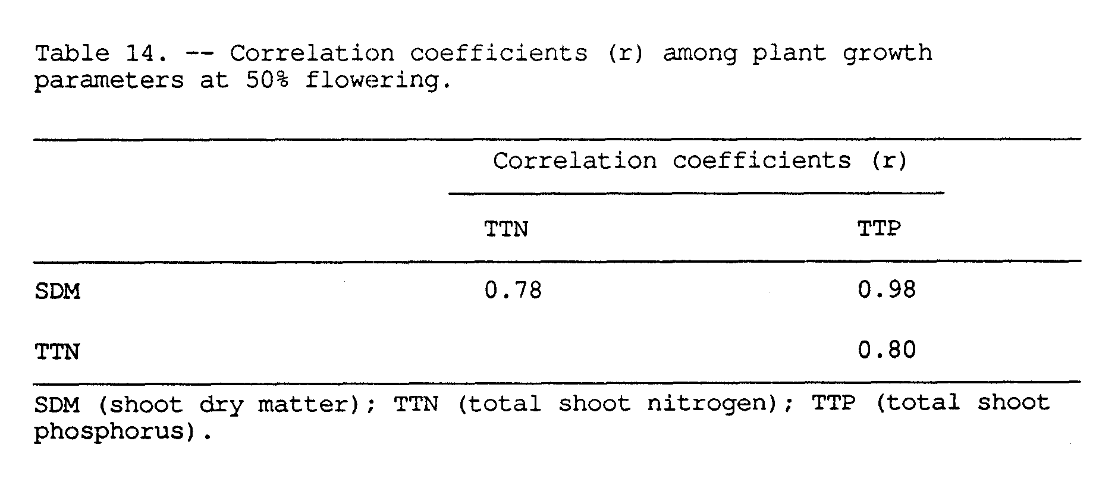

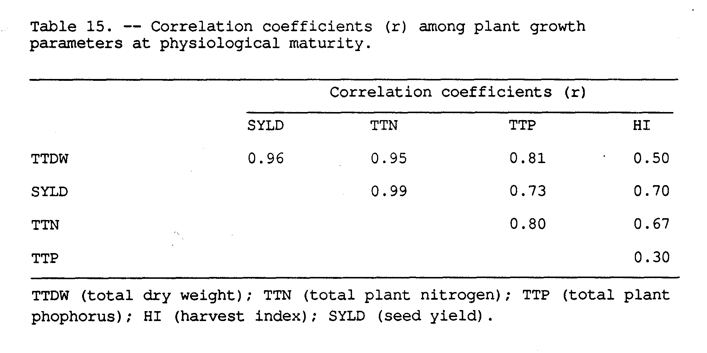
LITERATURE CITED

Adepetu, J.A. and R.B. Corey. 1977. Changes in N-and P availability and P fractions in Iwo soil from Nigeria under intensive cultivation. Plant and Soil 46:309-316.

Andrew, C.S. 1977. Nutritional restraints on legume symbiosis. pp. 253-274. Proc. of a workshop. Exploiting the legume - Rhizobium symbiosis in tropical agriculture. Univ. of Hawaii, College of Tropical Agriculture Misc. Publ. 145.

App, A. and A. Eaglesham. 1982. Biological nitrogen fixation problems and potential. pp. 1-7. In P.H. Graham and S.C. Harris (Eds.). Biological nitrogen fixation technology for tropical agriculture: Papers presented at a workshop held at C.I.A.T, March 9-13, 1981. Cali, Colombia, Centro Internacional de Agricultura Tropical.

Beck, D.P. and D.N. Munns. 1984. Phosphate nutrition of Rhizobium spp. Appl. Env. Micr. 47(2):278-282.

Bergesen, F.J. 1970. Some Australian studies relating to long term effects of inoculation of legume seed. Plant and Soil 32:727-736.

Bieleski, R.L. 1973. Phosphate pools, phosphate transport and phosphate availability. Ann. Rev. Plant Physiol. 24: 225-252.

Bohlool, B.B. and E.L Schmidt. 1973. Persistence and competition aspects of Rhizobium japonicum observed in soil by immunofluorescence. Soil Sci. Soc. Amer. 37:561-565.

Bonetti, R., M.N.S. Montanheiro, and M.T. Saito. 1984. The effects of phosphate and soil moisture on the nodulation and growth of Phaseolus vulgaris. J. Agric. Sci. Camb. 103:95-102.

Borst, H.L. and L.E. Thatcher. 1931. Life history and composition of the soybean plant. pp. 1-96. Ohio Agricultural Experiment Station Bulletin 494.

Brockwell, J. 1977. Application of legume seed inoculants. pp. 277-309. In R.W.F. Hardy and A.H. Gibson (Eds.). A treastise on dinitrogen fixation. John Wiley and Sons, Inc., New York.

, A. Diatloff, R.J. Roughley, and R.A. Date. 1982. Selection of rhizobia for inoculants. pp. 173-191. In J.M. Vincent (Ed.). Nitrogen fixation in legumes. Academic Press,
New York.
Burton, J.C. 1976. Problems in obtaining adequate inoculation of soybeans. pp. 170-179. In L.D. Hill (Ed.). World soybean research. Interstate Printers and Publishers, Inc. New York.

Caldwell, B.E. 1969. Initial competition of root-nodule bacteria on soybeans in a field environment. Agron. J. 61:813-815.

, and G. Vest. 1968. Nodulation interactions between soybean genotypes and serogroups of Rhizobium japonicum. Crop
Sci. 8:680-682.

Cassman, K.G., A.S. Whitney, and K.R. Stockinger. 1980. Root growth and dry matter distribution of soybean as affected by phosphorus stress, nodulation, and nitrogen source. Crop Sci. 20:239-243.

, , and R.L. Fox. 1981. Phosphorus requirements of soybean and cowpea as affected by mode of N
nutrition. Agron. J. 73:17-22.

, D.N. Munns, and D.P. Beck. 1981. Phosphorus nutrition of Rhizobium japonicum: strain differences in phosphate storage
and utilization. Soil Sci. Soc. Am. J. 45:517-520.

, , and , 1981. Growth of Rhizobium strains at low concentrations of phosphate. Soil Sci. Soc. Am.
J. 45:52-523.

Damirgi, S.M., L.R. Frederick, and I.C. Anderson. 1967. Serogroups of Rhizobium japonicum in soybean nodules as affected by soil types. Agron. J. 59:10-12.

Dart, P.J. 1977. Infection and development of leguminous nodules.
pp. 367-472. In R.W.F. Hardy and W.S. Silver (Eds.). A treastise on dinitrogen fixation III. John Wiley and Sons, Inc., New York.

Date, R.A. 1982. Assessment of Rhizobial status of the soil. pp. 85-94. In J.M Vincent (Ed.). Nitrogen fixation in legumes
Academic Press, New York.

Davis, L.C. 1980. Limiting factors in nitrogen fixation. What's New in Plant Physiology 11(11):41-45.

de Mooy, C.J. and J. Pesek. 1970. Differential effects of P, K, and Ca salts on leaf composition, yield, and seed size of soybean
lines. Crop Sci. 10:72-77.
Fox, R.L. (Unpublished). Diagnosing and correcting phosphorus problems in the humid tropics with special reference to the role
of mycorrhizae. Depatment of Agronomy and Soil Science, College
of Tropical Agriculture and Human Resourses, University of
Hawaii, Honolulu, Hawaii.

Fox, R.L. and E.J. Kamprath. 1970. Phosphate sorption isotherms for evaluating the phosphate requirements of soils. Soil Sci. Soc. Amer. Proc. 34(5):902-907.

and B.T. Kang. 1977. Some major fertility problems of tropical soils. pp. 183-210. Proc. of a workshop. Exploiting
the legume - Rhizobium symbiosis in tropical agriculture. Univ. of Hawaii, College of Tropical Agriculture Misc. Publ. 145.

and P.G.E. Searle. 1978. Phosphate absorption by soils of the tropics. University of Hawaii, Department of Agronomy and Soil Science. Hawaii Agricultural Experiment Station Journal Series No. 2236.

Franco, A.A. 1977. Nutritional restraints for tropical grain legume symbiosis. pp. 237-252. Proc. of a workshop. Exploiting the legume - Rhizobium symbiosis in tropical agriculture. Univ. of Hawaii, College of Tropical Agriculture Misc. Publ. 145.

and J.M. Vincent. 1976. Competition amongst rhizobial strains for the colonization and nodulation of two tropical legumes. Plant and Soil 47:27-48.

Gates, C.T. and J.R. Wilson. 1974. The interaction of nitrogen and phosphorus on the growth, nutrient status, and nodulation of Stylosanthes humilis H.B.K. (Townsville stylo). Plant and Soil 41:325-333.

Grunes, D.L. 1959. Effect of nitrogen on the availability of soil and fertilizer phosphates to plants. Adv. in Agr. 11:369-396.

Hanway, J.J. and C.R. Weber. 1971. Dry matter accumulation in eight soybean (Glycine max (L.) Merrill) varieties. Agron. J. 63:227-230.

and . 1971. Accumulation of N, P, and K by soybean (Glycine max (L.) Merill) plants. Agron. J. 63:406-408.

Herridge, D.F. 1982. Assessment of nitrogen fixation. pp. 123-136. In J.M. Vincent (Ed.). Nitrogen fixation in legumes. Academic Press, New York.

Hicks, D.R. 1978. Growth and development. In A.G. Norman (Ed.). Soybean physiology, agronomy, and utilization. Academic Press, New York.
Jardin Freire, J.R. 1977. Inoculation of soybeans. pp. 335-380. Proc. of a workshop. Exploiting the legume - Rhizobium symbiosis in tropical agriculture. Univ. of Hawaii, College of Tropical Agriculture Misc. Publ. 145.

Kamprath, E. J. and E.V. Miller. 1958. Soybean yields as a function of the soil phosphorus level. Soil Sci. Soc. Proc. 317-319.

Kang, B.T. and A.S.R. Juo. 1979. Balanced phosphate fertilization in humid West Africa. Phosphorus in Agriculture 76:75-85.

Kollman G.E., J.G. Streeter, D.L. Jeffers, and R.B. Curry. 1974. Accumulation and distribution of mineral nutrients, carbohydrate and dry matter in soybean plants as influenced by reproductive sink size. Agron. J. 66:549-553.

Kvien, C.S. and G.E. Ham. 1985. Effect of soil temperature and inoculum rate on the recovery of three introduced strains of Rhizobium japonicum. Agron. J. 77:484-489.

Labandera, C.A. and J.M Vincent. 1975. Competition between an introduced strain and native Uruguayan strains of Rhizobium trifolii. Plant and Soil 42:327-347.

Leggett, J.F. and M.M. Frere. 1971. Growth and nutrient uptake by soybean plants in nutrient solutions of graded concentrations. Plant Physiol. 48:457-460.

Marques Pinto, C., P. Y. Yao, and J. M. Vincent. 1974. Nodulating competitiveness amongst strains of Rhizobium meliloti and R. trifolii. Aust. J. Agric. Res. 25: 317-329.

Materon, L.A. and J.M. Vincent. 1980. Host specificity and interstrain competition with soybean rhizobia. Field Crops Res. 3:215-224.

McNeil, D.L. 1982. Quantification of symbiotic nitrogen fixation using ureides: a review. pp. 609-618. In P.H. Graham and S.C. Harris (Eds.). Biological nitrogen fixation for tropical agriculture: Papers presented at a workshop held at C.I.A.T., March 9-31, 1981. Cali, Columbia, Centro Internacional de Agricultura Tropical.

Miller, M.H. and A.J. Ohlrogge. 1957. Principles of nutrient uptake from fertilizer bands. 1. Effect of placement of nitrogen fertilizer on the uptake of band-placed phosphorus at different soil phosphorus levels. Agron. J. 50:95-97.
Moawad, H. and B.B. Bohlool. 1984. Competition among Rhizobium spp. for nodulation of leucaena leucocephala in two tropical soils. Appl. Env. Micr. 48(1):5-9.

Moody, P.W., G.F. Haydon, and T. Dickerson. 1983. Mineral nutrition of soybeans grown in South Burnett region of south-eastern Queensland. 2. Prediction of grain yield response to phosphorus with soil tests.

Munns, D.N. 1977. Soil acidity and related problems. pp. 211-236. Proc. of a workshop. Exploiting the legume - Rhizobium symbiosis in tropical agriculture. Univ. of Hawaii, College of Tropical Agriculture Misc. Publ. 145.

and A. A. Franco. 1982. Soil constraints to legume production. pp. 133-152. In P. H. Graham and S. C. Harris (Eds.). Biologocal nitrogen fixation technology for tropical agriculture: Papers presented at a workshop held at C.I.A.T., March 9-13 1981. Cali, Colombia, Centro Internacional de Agricultura Tropical.

Rayar, A.J. and T.V. Hai. 1977. Effect of ammonium on uptake of phosphorus, pottasium, calcium, and magnesium by intact soybean plants. Plant and Soil 48:81-87.

Russell, E.W. 1973. The individual nutrients needed by plants. pp. 31-48. In E.W. Russel (Ed.). Soil conditions and plant growth, 10th edition. Longman, London and New York.

Sanchez, P.A. 1976. Properties and management of soils in the tropics. John Wiley and Sons, Inc., New York.

Shanmugan, K.T., F. O'Gara, K. Andersen, and R.C. Valentine. 1978. Biological nitrogen fixation. Ann. Rev. Plant Physiol. 29:263-276.

Singleton, P.W., S.A. E1 Swaify, and B.B. Bohlool. 1982. Effect of salinity on Rhizobium growth and survival. Appl. Env. Micr. 44(4) :884-890.

and K.R. Stockinger. 1983. Compensation against ineffective nodulation in soybean. Crop Sci. 23:69-72.

, H.M. AbdelMagid, and J.W. Tavares. 1985. Effect of phosphorus on the effectiveness of strains of Rhizobium japonicum. Soil Sci. Soc. Am. J. 49(3):613-616.

Sloger, C. 1976. Biochemistry of N₂ fixation. pp. 125-133. In L.D. Hill (Ed.). World soybean research. The Interstate Publishers, Inc. New York.
Smith, R.S., M.A. Ellis, and R.E. Smith. 1981. Effect of Rhizobium japonicum inoculant rates on soybean nodulation in a tropical soil. Agron. J. 73:505-508.

Soil survey interpretations. Maui. Report R45. 1972. pp. 17-18. United States Department of Agriculture, Soil conservation service, Honolulu, Hawaii.

Soil survey of Islands of Kauai, Oahu, Maui, Molokai, and Lanai, State of Hawaii. 1972. pp. 31-32, 218-219. United States Department of Agriculture, Soil conservation service.

Somasegaran, P., R. Woolfenden, and J. Halliday. 1983. Suitability of oven-dried root nodules for Rhizobium strain identification by immunofluorescence and agglutination. J. Appl. Bact., 55: 253-261.

, and H.J. Hoben. 1985. Methods in legume - Rhizobium technology. University of Hawaii Niftal Project and MIRCEM. Department of Agronomy and Soil Science, University of Hawaii.

Stangel, P.J. 1979. Nitrogen requirement and adequacy of supply for rice production. pp. 45-69. In Nitrogen and rice. Inter. Rice Res. Inst., Los Banos, Philipines.

Trinick, M.J. 1982. Host-Rhizobium associations. pp. 111-122. In J.M. Vincent (ed.) Nitrogen fixation in legumes. Academic Press, New York.

Uehara, G. 1977. An overview of soils of the arable tropics. pp. 183-210. Proc. of a workshop. Exploiting the legume - Rhizobium symbiosis in tropical agriculture. Univ. of Hawaii, College of Tropical Agriculture Misc. Publ. 145.

Velayutham, M. 1980. The problem of phosphate fixation by minerals and soil colloids. Phosphorus in agriculture 77:1-7.

Viets Jr., F.G. 1965. The plant's need for and use of nitrogen. pp. 503-549. In W.V. Batholomew and F.E. Clark (Eds.). Soil nitrogen. American Society of Agronomy, Inc., Madison, Wisconsin.

Vose, P.B., A.P. Ruschel, R.L. Vicotria, S.M.T. Saito, and E. Matsui. 1982. ¹⁵N research as a tool in biological nitrogen fixation research. pp. 575-592. In P.H. Graham and S.C. Harris (Eds.). Biological nitrogen fixation for tropical agriculture: Papers presented at a workshop held at C.I.A.T., March 9-13, 1981. Cali, Colombia, Centro Internacional de Agricultura Tropical.
Weaver, R.W. and L.R. Fredericks. 1972. Effect of inoculum size on nodulation of Glycine max (L.) Merrill variety ford. Agron. J. 64:597-599.

and 1974. Effect of inoculum rate on competitive nodulation of Glycine max (L.) Merrill. II. Field studies. Agron. J. 66:233-236.

White, R.E. 1973. Studies on mineral ion absorption by plants. II. The interaction between metabolic activity and rate of phosphorus uptake. Plant and Soil 38:509-523.

